DAA LAB

CSA0601

U.Prabhavathi(192472067)

TOPIC 1 – INTRODUCTION

1. Bubble Sort
Aim:
To sort the given array in ascending order using Bubble Sort.
Algorithm:
- Read the array elements.
- Compare adjacent elements.
- Swap if they are in the wrong order.
- Repeat until the array is sorted.
- Display the sorted array.
Program
#include <stdio.h>

int main()
{
int a[100], n, i, j, temp;

printf("Enter the number of elements: ");
scanf("%d", &n);

printf("Enter the elements:\n");
for(i = 0; i < n; i++)
scanf("%d", &a[i]);

for(i = 0; i < n - 1; i++)
{
for(j = 0; j < n - i - 1; j++)
{
if(a[j] > a[j + 1])
{
temp = a[j];
a[j] = a[j + 1];
a[j + 1] = temp;
}
}
}

printf("Sorted array: ");
for(i = 0; i < n; i++)
printf("%d ", a[i]);

return 0;
}
Output
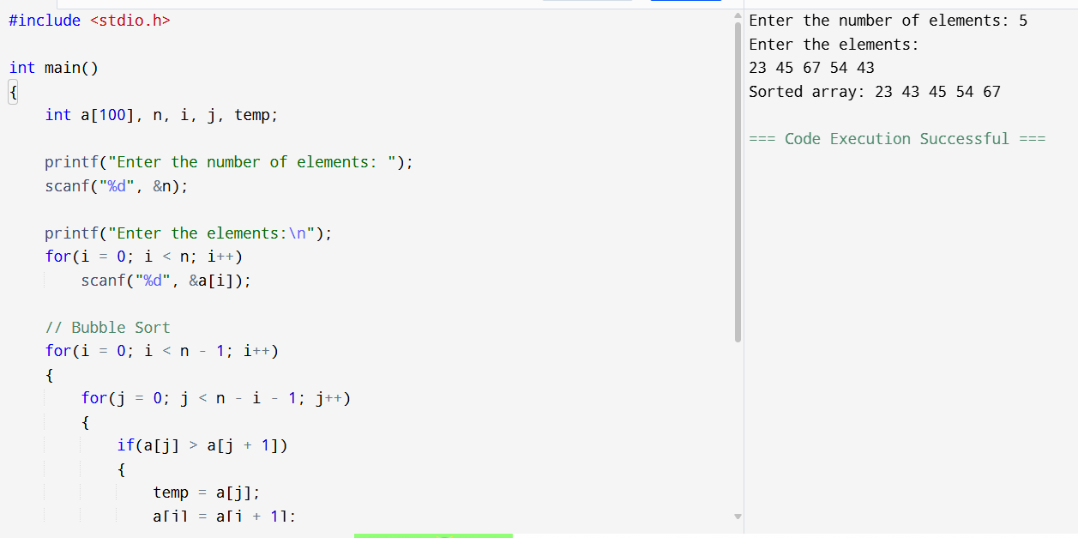
Result:
The array is sorted successfully using Bubble Sort.

2. Find Maximum Element
Aim:
To find the maximum element in the given array.
Algorithm:
- Read the array elements.
- Assume the first element is maximum.
- Compare it with the remaining elements.
- Update the maximum if a larger element is found.
- Display the maximum element.
Program
#include <stdio.h>

int main()
{
int a[100],n,i,max;

printf("Enter number of elements: ");
scanf("%d",&n);

printf("Enter elements:\n");
for(i=0;i<n;i++)
scanf("%d",&a[i]);

max=a[0];

for(i=1;i<n;i++)
{
if(a[i]>max)
max=a[i];
}

printf("Maximum element = %d",max);

return 0;
}
Output
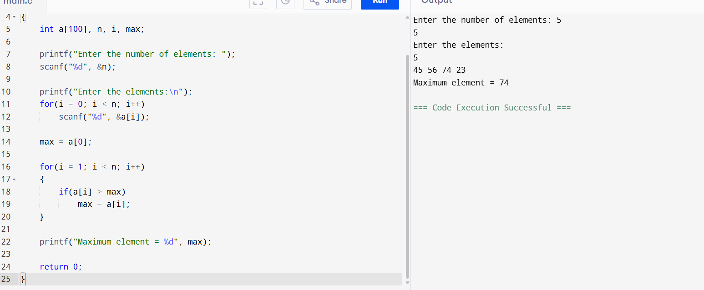
Result:
The maximum element is found successfully.

3. Sort and Find Maximum
Aim:
To sort the array and find the maximum element.
Algorithm:
- Read the array.
- Sort it using Bubble Sort.
- The last element is the maximum.
- Display the sorted array and maximum element.
Program
#include <stdio.h>

int main()
{
int a[100],n,i,j,temp;

printf("Enter number of elements: ");
scanf("%d",&n);

printf("Enter elements:\n");
for(i=0;i<n;i++)
scanf("%d",&a[i]);

for(i=0;i<n-1;i++)
{
for(j=0;j<n-i-1;j++)
{
if(a[j]>a[j+1])
{
temp=a[j];
a[j]=a[j+1];
a[j+1]=temp;
}
}
}

printf("Sorted array:\n");
for(i=0;i<n;i++)
printf("%d ",a[i]);

printf("\nMaximum element = %d",a[n-1]);

return 0;
}
Output
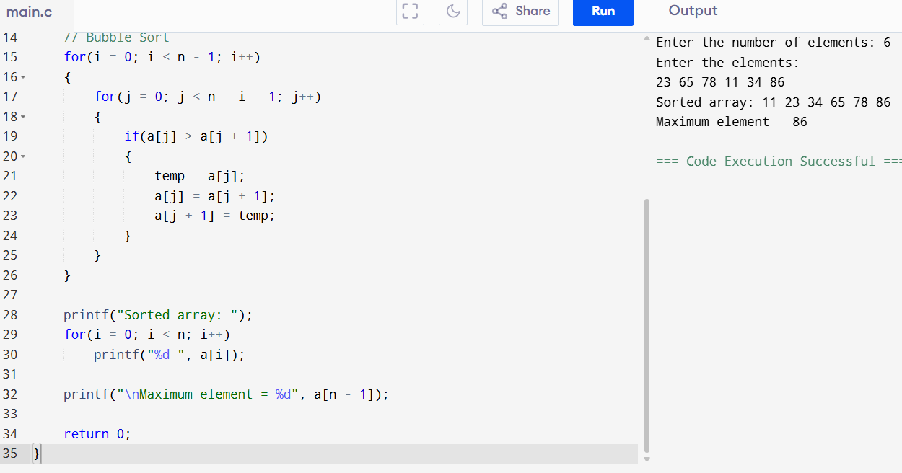
Result:
The array is sorted and the maximum element is displayed successfully.

4. Binary Search
Aim:
To search an element using Binary Search.
Algorithm:
- Read the sorted array.
- Find the middle element.
- Compare it with the key.
- Search the left or right half accordingly.
- Display whether the element is found.
Program
#include <stdio.h>

int main()
{
int a[100],n,i,key,low,high,mid;

printf("Enter number of elements: ");
scanf("%d",&n);

printf("Enter sorted elements:\n");
for(i=0;i<n;i++)
scanf("%d",&a[i]);

printf("Enter element to search: ");
scanf("%d",&key);

low=0;
high=n-1;

while(low<=high)
{
mid=(low+high)/2;

if(a[mid]==key)
{
printf("Element found at position %d",mid+1);
return 0;
}
else if(a[mid]<key)
low=mid+1;
else
high=mid-1;
}

printf("Element not found");

return 0;
}
Output
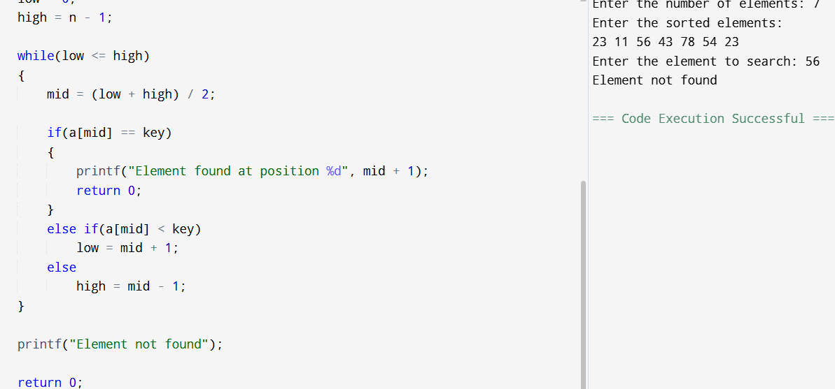
Result:
The required element is searched successfully using Binary Search.

5. Efficient Sorting (Quick Sort)
Aim:
To sort the array using Quick Sort.
Algorithm:
- Select a pivot element.
- Partition the array.
- Recursively sort both partitions.
- Display the sorted array.
Program
#include <stdio.h>

void quicksort(int a[], int low, int high);
int partition(int a[], int low, int high);

int main()
{
int a[100], n, i;

printf("Enter number of elements: ");
scanf("%d", &n);

printf("Enter elements:\n");
for(i = 0; i < n; i++)
scanf("%d", &a[i]);

quicksort(a, 0, n - 1);

printf("Sorted array:\n");
for(i = 0; i < n; i++)
printf("%d ", a[i]);

return 0;
}

void quicksort(int a[], int low, int high)
{
int p;
if(low < high)
{
p = partition(a, low, high);
quicksort(a, low, p - 1);
quicksort(a, p + 1, high);
}
}

int partition(int a[], int low, int high)
{
int pivot = a[high];
int i = low - 1, j, temp;

for(j = low; j < high; j++)
{
if(a[j] < pivot)
{
i++;
temp = a[i];
a[i] = a[j];
a[j] = temp;
}
}

temp = a[i + 1];
a[i + 1] = a[high];
a[high] = temp;

return i + 1;
}
Output
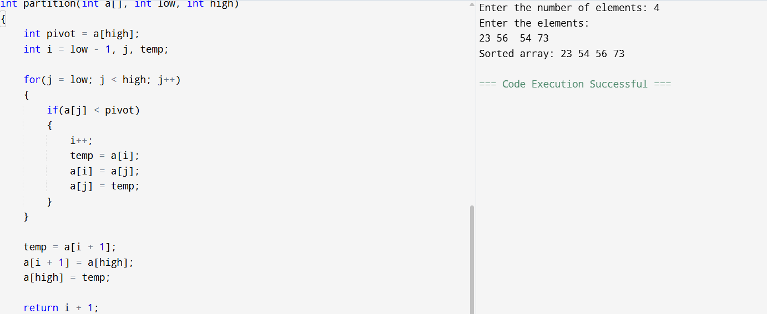
Result:
The array is sorted successfully using Quick Sort.

6. String Comparison Using Stack
Aim:
To compare two strings using stacks.
Algorithm:
- Read two strings.
- Push each string into separate stacks.
- Compare the characters.
- Display whether the strings are equal or not.
Program
#include <stdio.h>
#include <string.h>

char stack1[100], stack2[100];
int top1=-1, top2=-1;

void push1(char ch)
{
stack1[++top1]=ch;
}

void push2(char ch)
{
stack2[++top2]=ch;
}

int main()
{
char str1[100], str2[100];
int i;

printf("Enter first string: ");
scanf("%s",str1);

printf("Enter second string: ");
scanf("%s",str2);

for(i=0; str1[i]!='\0'; i++)
push1(str1[i]);

for(i=0; str2[i]!='\0'; i++)
push2(str2[i]);

if(top1!=top2)
{
printf("Strings are not equal");
return 0;
}

while(top1>=0)
{
if(stack1[top1]!=stack2[top2])
{
printf("Strings are not equal");
return 0;
}
top1--;
top2--;
}

printf("Strings are equal");

return 0;
}
Output
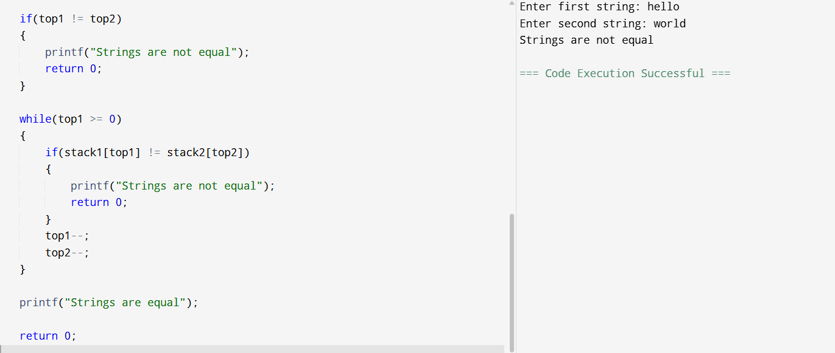
Result:
The strings are compared successfully using stacks.

TOPIC 2 – BRUTE FORCE

1. List Operations
Aim:
To perform insertion, deletion, and display operations on a list.
Algorithm:
- Read the list elements.
- Select the required operation.
- Perform insertion or deletion.
- Display the updated list.
Program
#include <stdio.h>

int main()
{
int a[100], n, i, pos, ele, choice;

printf("Enter number of elements: ");
scanf("%d",&n);

printf("Enter elements:\n");
for(i=0;i<n;i++)
scanf("%d",&a[i]);

printf("1.Insert\n2.Delete\n3.Display\n");
printf("Enter choice: ");
scanf("%d",&choice);

switch(choice)
{
case 1:
printf("Enter position and element: ");
scanf("%d%d",&pos,&ele);

for(i=n;i>=pos;i--)
a[i]=a[i-1];

a[pos-1]=ele;
n++;
break;

case 2:
printf("Enter position: ");
scanf("%d",&pos);

for(i=pos-1;i<n-1;i++)
a[i]=a[i+1];

n--;
break;
}

printf("List elements:\n");

for(i=0;i<n;i++)
printf("%d ",a[i]);

return 0;
}
Output
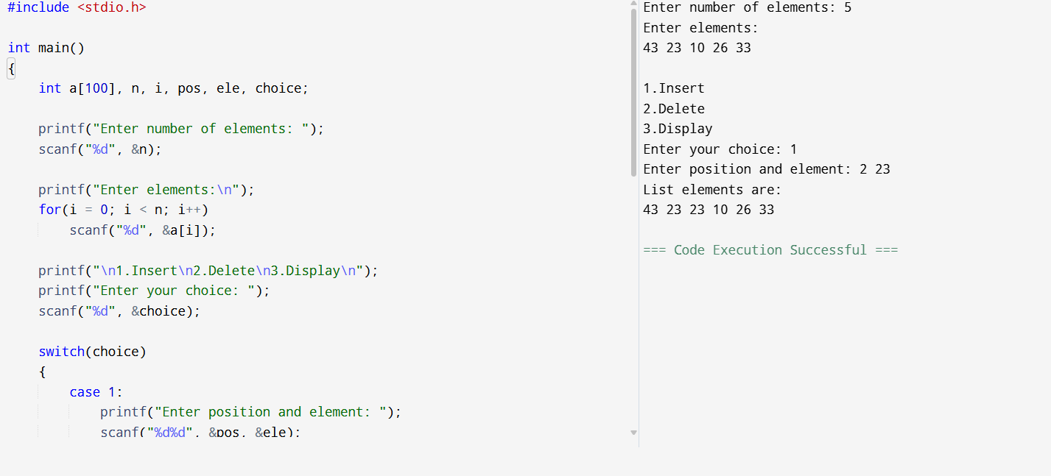
Result:
The list operations are performed successfully.

2. Selection Sort
Aim:
To sort the array using Selection Sort.
Algorithm:
- Find the minimum element.
- Swap it with the first unsorted element.
- Repeat until sorted.
- Display the sorted array.
Program
#include <stdio.h>

int main()
{
int a[100], n, i, j, min, temp;

printf("Enter number of elements: ");
scanf("%d",&n);

printf("Enter elements:\n");
for(i=0;i<n;i++)
scanf("%d",&a[i]);

for(i=0;i<n-1;i++)
{
min=i;

for(j=i+1;j<n;j++)
{
if(a[j]<a[min])
min=j;
}

temp=a[i];
a[i]=a[min];
a[min]=temp;
}

printf("Sorted array:\n");

for(i=0;i<n;i++)
printf("%d ",a[i]);

return 0;
}
Output
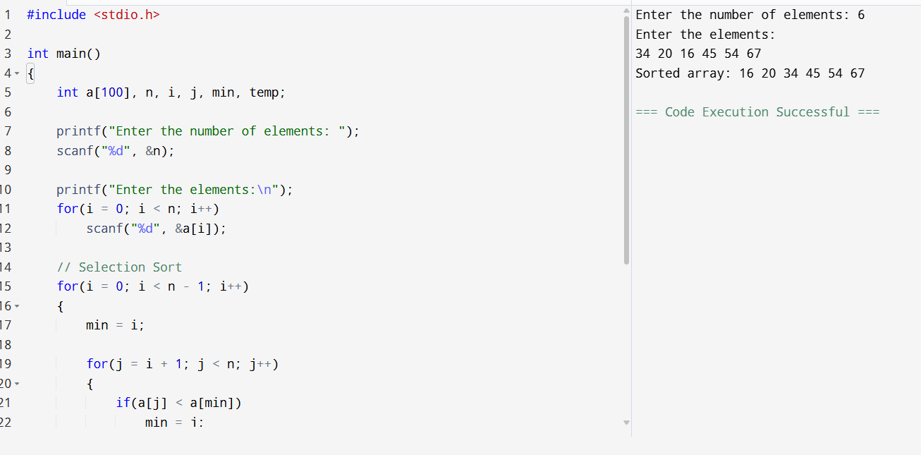
Result:
The array is sorted successfully using Selection Sort.

3. Insertion Sort
Aim:
To sort the array using Insertion Sort.
Algorithm:
- Assume the first element is sorted.
- Insert each remaining element into its correct position.
- Repeat for all elements.
- Display the sorted array.
Program
#include <stdio.h>

int main()
{
int a[100], n, i, j, key;

printf("Enter number of elements: ");
scanf("%d",&n);

printf("Enter elements:\n");
for(i=0;i<n;i++)
scanf("%d",&a[i]);

for(i=1;i<n;i++)
{
key=a[i];
j=i-1;

while(j>=0 && a[j]>key)
{
a[j+1]=a[j];
j--;
}

a[j+1]=key;
}

printf("Sorted array:\n");

for(i=0;i<n;i++)
printf("%d ",a[i]);

return 0;
}
Output
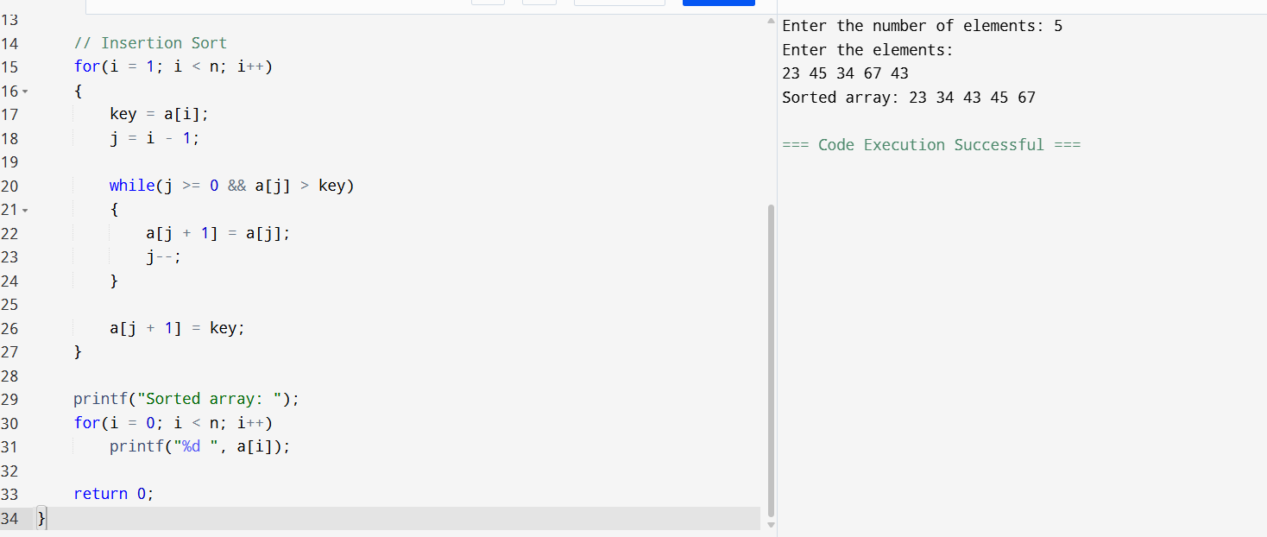
Result:
The array is sorted successfully using Insertion Sort.

4. Optimized Bubble Sort
Aim:
To sort the array using Optimized Bubble Sort.
Algorithm:
- Compare adjacent elements.
- Swap if necessary.
- Use a flag to detect swaps.
- Stop if no swaps occur.
- Display the sorted array.
Program
#include <stdio.h>

int main()
{
int a[100], n, i, j, temp, swapped;

printf("Enter number of elements: ");
scanf("%d",&n);

printf("Enter elements:\n");
for(i=0;i<n;i++)
scanf("%d",&a[i]);

for(i=0;i<n-1;i++)
{
swapped=0;

for(j=0;j<n-i-1;j++)
{
if(a[j]>a[j+1])
{
temp=a[j];
a[j]=a[j+1];
a[j+1]=temp;
swapped=1;
}
}

if(swapped==0)
break;
}

printf("Sorted array:\n");

for(i=0;i<n;i++)
printf("%d ",a[i]);

return 0;
}
Output
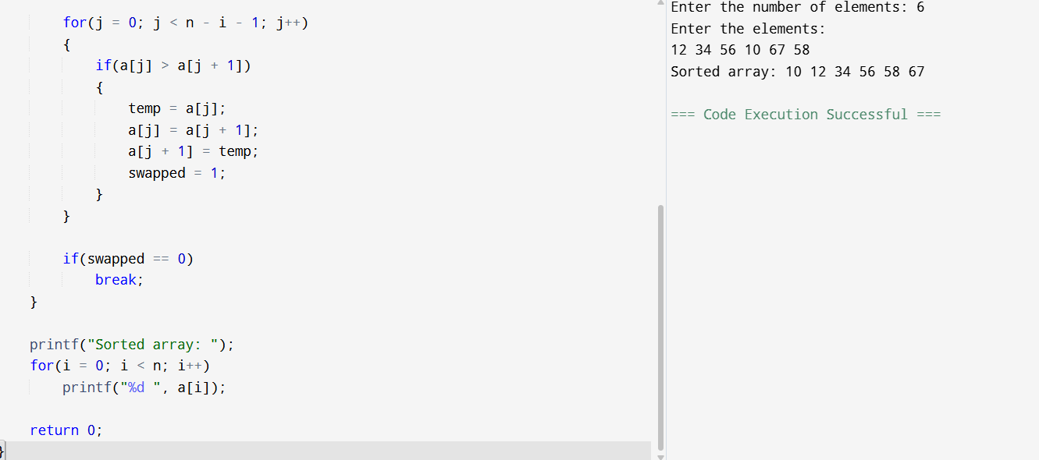
Result:
The array is sorted successfully using Optimized Bubble Sort.

5. Closest Pair of Points
Aim:
To find the closest pair of points using the brute-force method.
Algorithm:
- Read all points.
- Calculate the distance between every pair.
- Find the minimum distance.
- Display the closest distance.
Program
#include <stdio.h>
#include <math.h>

struct Point
{
int x, y;
};

int main()
{
struct Point p[100];
int n, i, j;
float dist, min;

printf("Enter number of points: ");
scanf("%d",&n);

printf("Enter coordinates:\n");

for(i=0;i<n;i++)
scanf("%d%d",&p[i].x,&p[i].y);

min=sqrt(pow(p[0].x-p[1].x,2)+pow(p[0].y-p[1].y,2));

for(i=0;i<n;i++)
{
for(j=i+1;j<n;j++)
{
dist=sqrt(pow(p[i].x-p[j].x,2)+pow(p[i].y-p[j].y,2));

if(dist<min)
min=dist;
}
}

printf("Minimum Distance = %.2f",min);

return 0;
}
Output
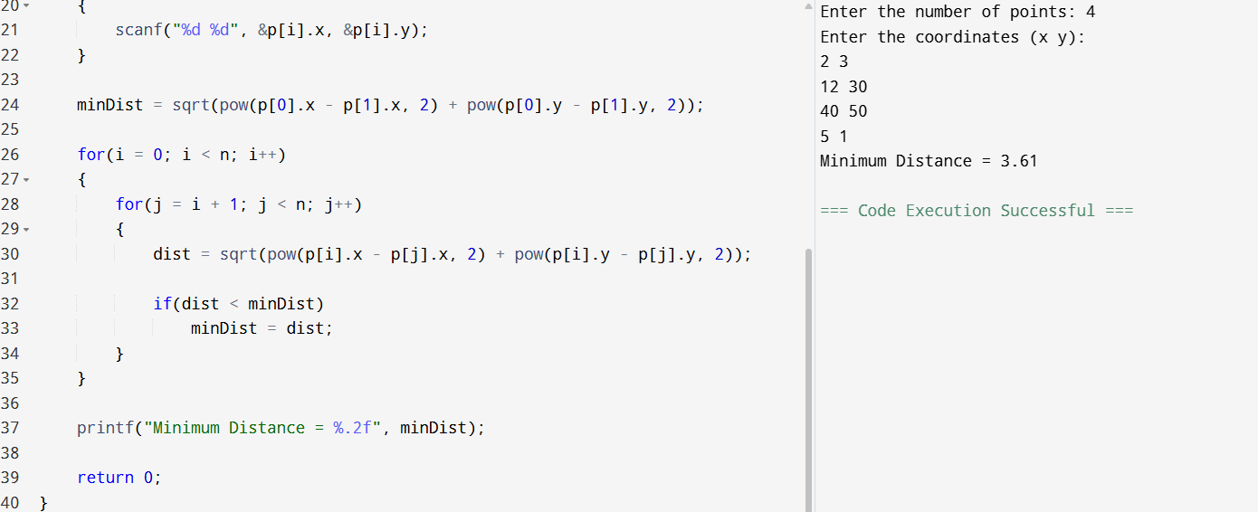
Result:
The closest pair of points is found successfully.

6. Convex Hull (Brute Force)
Aim:
To find the Convex Hull using the brute-force method.
Algorithm:
- Read all points.
- Consider every pair of points.
- Check whether all other points lie on the same side.
- Display the Convex Hull edges.
Program
#include <stdio.h>

struct Point
{
int x, y;
};

int main()
{
struct Point p[100];
int n, i, j, k;

printf("Enter number of points: ");
scanf("%d",&n);

printf("Enter coordinates:\n");

for(i=0;i<n;i++)
scanf("%d%d",&p[i].x,&p[i].y);

printf("Convex Hull Edges:\n");

for(i=0;i<n;i++)
{
for(j=i+1;j<n;j++)
{
int left=0,right=0;

for(k=0;k<n;k++)
{
int value=(p[j].x-p[i].x)*(p[k].y-p[i].y)-
(p[j].y-p[i].y)*(p[k].x-p[i].x);

if(value>0)
left++;
else if(value<0)
right++;
}

if(left==0 || right==0)
{
printf("(%d,%d) -> (%d,%d)\n",
p[i].x,p[i].y,p[j].x,p[j].y);
}
}
}

return 0;
}
Output
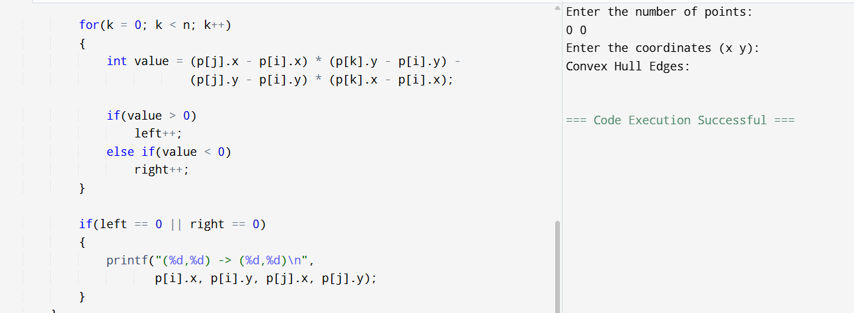
Result:
The Convex Hull is obtained successfully using the brute-force method.

7. Convex Hull Program (Jarvis March)
Aim:
To find the Convex Hull using Jarvis March algorithm.
Algorithm:
- Find the leftmost point.
- Select the next counter-clockwise point.
- Repeat until the starting point is reached.
- Display the Convex Hull.
Program
#include <stdio.h>

struct Point
{
int x, y;
};

int orientation(struct Point p, struct Point q, struct Point r)
{
int val = (q.y - p.y) * (r.x - q.x) -
(q.x - p.x) * (r.y - q.y);

if(val == 0)
return 0;
return (val > 0) ? 1 : 2;
}

void convexHull(struct Point points[], int n)
{
if(n < 3)
return;

int hull[100];
int left = 0, p, q, i, count = 0;

for(i = 1; i < n; i++)
if(points[i].x < points[left].x)
left = i;

p = left;

do
{
hull[count++] = p;
q = (p + 1) % n;

for(i = 0; i < n; i++)
if(orientation(points[p], points[i], points[q]) == 2)
q = i;

p = q;

} while(p != left);

printf("Convex Hull Points:\n");

for(i = 0; i < count; i++)
printf("(%d,%d)\n", points[hull[i]].x, points[hull[i]].y);
}

int main()
{
struct Point points[100];
int n, i;

printf("Enter number of points: ");
scanf("%d", &n);

printf("Enter coordinates:\n");
for(i = 0; i < n; i++)
scanf("%d%d", &points[i].x, &points[i].y);

convexHull(points, n);

return 0;
}
Output
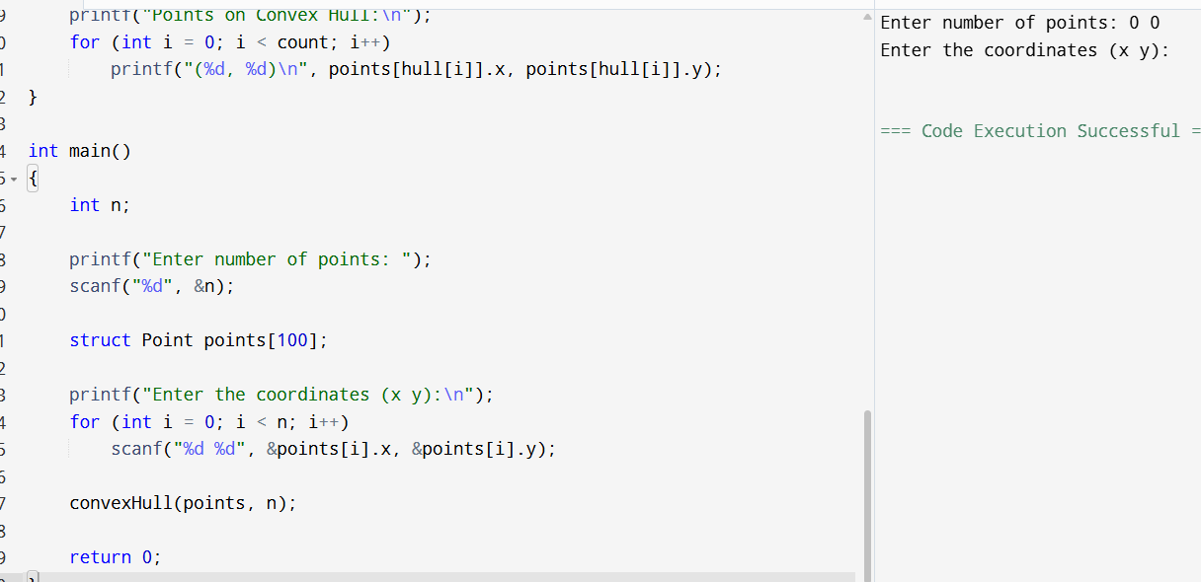
Result:
The Convex Hull is obtained successfully using Jarvis March.

8. Travelling Salesman Problem
Aim:
To find the minimum cost path for visiting all cities.
Algorithm:
- Read the cost matrix.
- Start from the first city.
- Visit the nearest unvisited city.
- Return to the starting city.
- Display the minimum cost.
Program
#include <stdio.h>

int main()
{
int cost[10][10], visited[10];
int n, i, j, city = 0, next;
int min, mincost = 0;

printf("Enter number of cities: ");
scanf("%d", &n);

printf("Enter cost matrix:\n");

for(i = 0; i < n; i++)
{
visited[i] = 0;

for(j = 0; j < n; j++)
scanf("%d", &cost[i][j]);
}

visited[0] = 1;

printf("Path: 1");

for(i = 0; i < n - 1; i++)
{
min = 999;

for(j = 0; j < n; j++)
{
if(!visited[j] && cost[city][j] < min)
{
min = cost[city][j];
next = j;
}
}

visited[next] = 1;
mincost += min;
city = next;

printf(" -> %d", next + 1);
}

mincost += cost[city][0];

printf(" -> 1");
printf("\nMinimum Cost = %d", mincost);

return 0;
}
Output
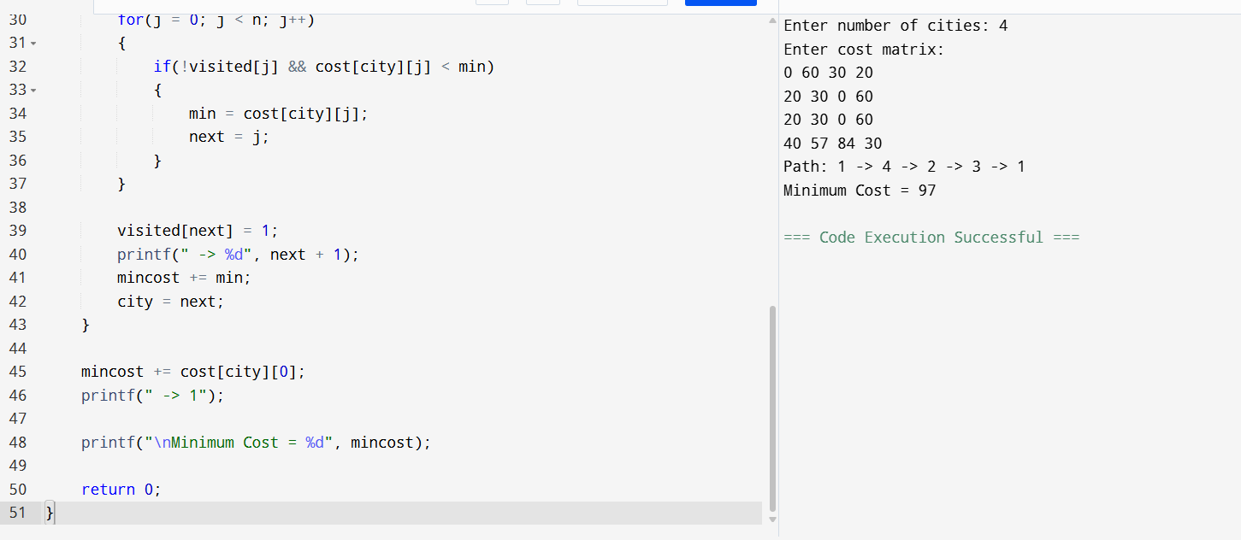
Result:
The minimum cost path is obtained successfully.

9. Assignment Problem
Aim:
To assign jobs to workers with minimum cost.
Algorithm:
- Read the cost matrix.
- Assign the minimum-cost unassigned job.
- Repeat for all workers.
- Display the assignments and total cost.
Program
#include <stdio.h>

int main()
{
int cost[10][10], assigned[10] = {0};
int n, i, j, job;
int min, total = 0;

printf("Enter number of workers/jobs: ");
scanf("%d", &n);

printf("Enter cost matrix:\n");

for(i = 0; i < n; i++)
for(j = 0; j < n; j++)
scanf("%d", &cost[i][j]);

printf("Assignments:\n");

for(i = 0; i < n; i++)
{
min = 999;

for(j = 0; j < n; j++)
{
if(!assigned[j] && cost[i][j] < min)
{
min = cost[i][j];
job = j;
}
}

assigned[job] = 1;
total += min;

printf("Worker %d -> Job %d\n", i + 1, job + 1);
}

printf("Minimum Cost = %d", total);

return 0;
}
Output
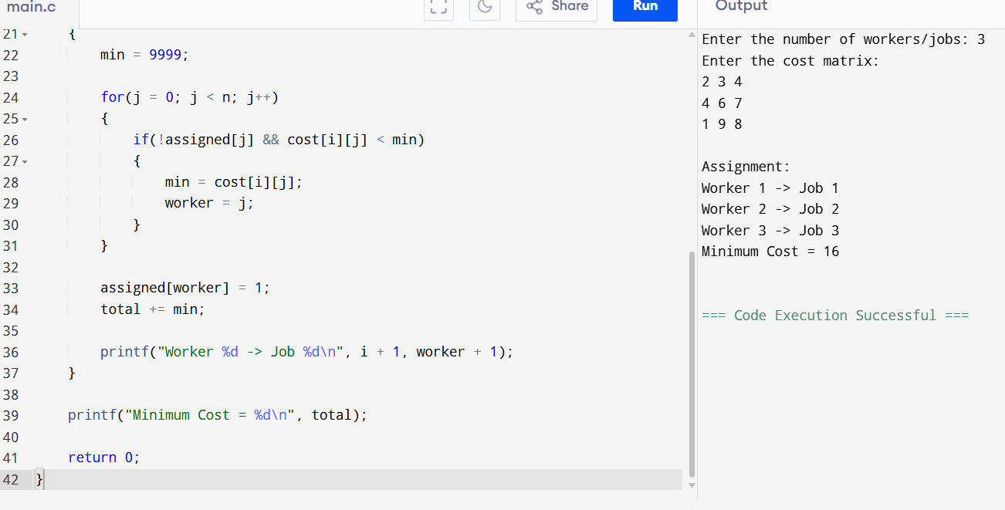
Result:
The assignment problem is solved successfully.

10. Knapsack (0/1 Knapsack)
Aim:
To find the maximum profit using the 0/1 Knapsack algorithm.
Algorithm:
- Read the weights, profits, and capacity.
- Build the Dynamic Programming table.
- Find the maximum profit.
- Display the result.
Program
#include <stdio.h>

int max(int a, int b)
{
if(a > b)
return a;
else
return b;
}

int main()
{
int n, W, i, j;

printf("Enter number of items: ");
scanf("%d", &n);

int wt[n], val[n];

printf("Enter weights:\n");
for(i = 0; i < n; i++)
scanf("%d", &wt[i]);

printf("Enter profits:\n");
for(i = 0; i < n; i++)
scanf("%d", &val[i]);

printf("Enter capacity: ");
scanf("%d", &W);

int dp[n + 1][W + 1];

for(i = 0; i <= n; i++)
{
for(j = 0; j <= W; j++)
{
if(i == 0 || j == 0)
dp[i][j] = 0;
else if(wt[i - 1] <= j)
dp[i][j] = max(val[i - 1] + dp[i - 1][j - wt[i - 1]],
dp[i - 1][j]);
else
dp[i][j] = dp[i - 1][j];
}
}

printf("Maximum Profit = %d", dp[n][W]);

return 0;
}
Output
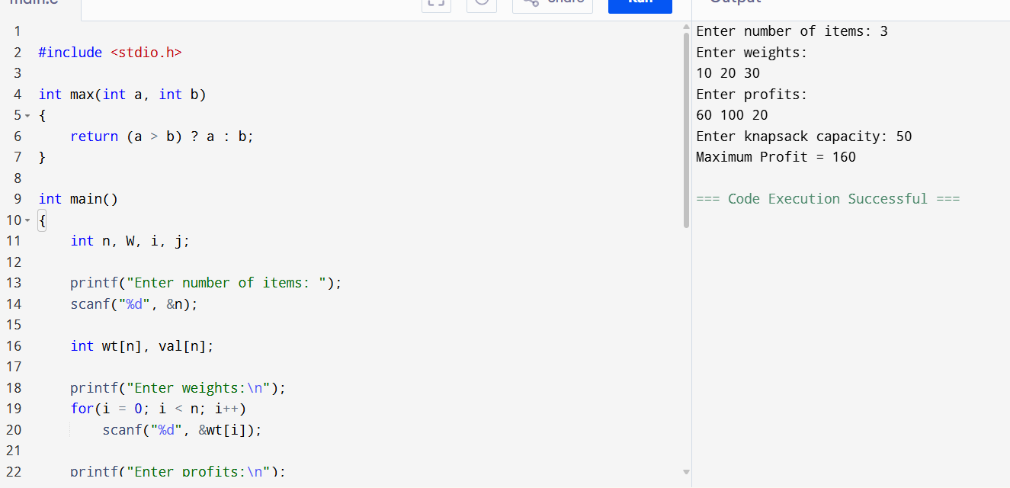
Result:
The maximum profit is obtained successfully using the 0/1 Knapsack algorithm.

TOPIC-3 DIVIDE AND CONQUER

1. Maximum and Minimum in an Array

Aim
To find the maximum and minimum elements in an unsorted array.

Algorithm
- Read the array elements.
- Assume the first element as both maximum and minimum.
- Compare each element with maximum and minimum.
- Update maximum and minimum values.
- Display the results.

C Code
#include <stdio.h>

int main() {
int n, a[100], i, max, min;

scanf("%d", &n);

for(i=0;i<n;i++)
scanf("%d",&a[i]);

max=min=a[0];

for(i=1;i<n;i++){
if(a[i]>max)
max=a[i];
if(a[i]<min)
min=a[i];
}

printf("Maximum = %d\n",max);
printf("Minimum = %d",min);

return 0;
}
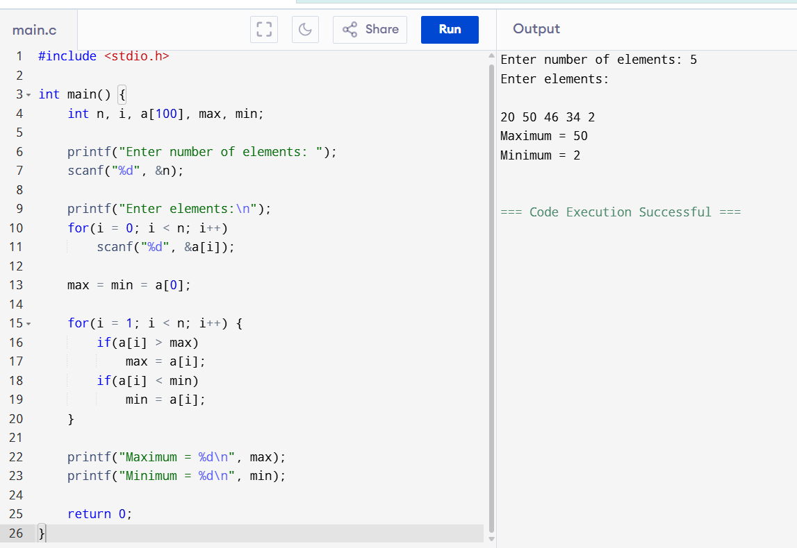

Result
The maximum and minimum elements in the array were found successfully.

2. Maximum and Minimum in a Sorted Array

Aim
To find the maximum and minimum elements in a sorted array.

Algorithm
- Read the sorted array.
- First element is the minimum.
- Last element is the maximum.
- Display both values.

C Code
#include <stdio.h>

int main() {
int n,a[100],i;

scanf("%d",&n);

for(i=0;i<n;i++)
scanf("%d",&a[i]);

printf("Minimum = %d\n",a[0]);
printf("Maximum = %d",a[n-1]);

return 0;
}
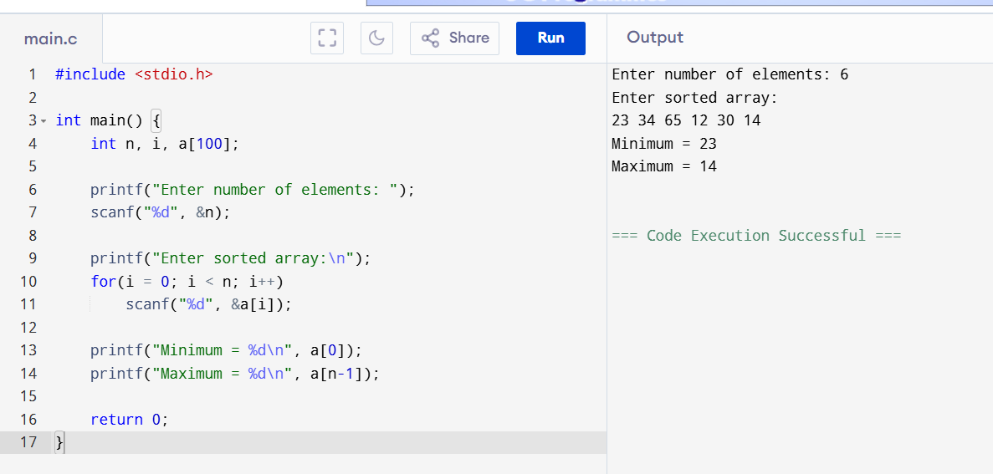

Result
The maximum and minimum elements of the sorted array were displayed successfully.

3. Merge Sort

Aim
To sort an array using Merge Sort.

Algorithm
- Divide the array into two halves.
- Recursively sort both halves.
- Merge the sorted halves.
- Repeat until the entire array is sorted.

C Code
#include<stdio.h>

void merge(int a[],int l,int m,int r){
int i=l,j=m+1,k=0,temp[100];

while(i<=m&&j<=r){
if(a[i]<a[j])
temp[k++]=a[i++];
else
temp[k++]=a[j++];
}

while(i<=m)
temp[k++]=a[i++];

while(j<=r)
temp[k++]=a[j++];

for(i=l,k=0;i<=r;i++,k++)
a[i]=temp[k];
}

void mergesort(int a[],int l,int r){
if(l<r){
int m=(l+r)/2;
mergesort(a,l,m);
mergesort(a,m+1,r);
merge(a,l,m,r);
}
}

int main(){
int n,a[100],i;

scanf("%d",&n);

for(i=0;i<n;i++)
scanf("%d",&a[i]);

mergesort(a,0,n-1);

for(i=0;i<n;i++)
printf("%d ",a[i]);

return 0;
}
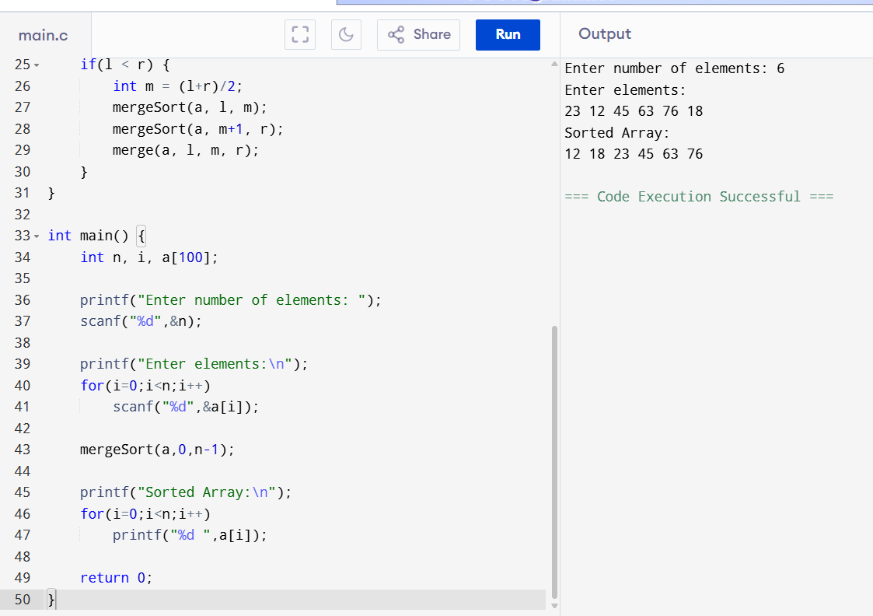

Result
The array was sorted successfully using Merge Sort.

4. Merge Sort with Comparison Count

Aim
To sort an array using Merge Sort and count the number of comparisons.

Algorithm
- Divide the array recursively.
- Merge sorted arrays.
- Count every comparison during merging.
- Display the sorted array and comparison count.

C Code
#include<stdio.h>

int count=0;

void merge(int a[],int l,int m,int r){
int i=l,j=m+1,k=0,temp[100];

while(i<=m&&j<=r){
count++;
if(a[i]<a[j])
temp[k++]=a[i++];
else
temp[k++]=a[j++];
}

while(i<=m)
temp[k++]=a[i++];

while(j<=r)
temp[k++]=a[j++];

for(i=l,k=0;i<=r;i++,k++)
a[i]=temp[k];
}

void mergesort(int a[],int l,int r){
if(l<r){
int m=(l+r)/2;
mergesort(a,l,m);
mergesort(a,m+1,r);
merge(a,l,m,r);
}
}

int main(){
int n,a[100],i;

scanf("%d",&n);

for(i=0;i<n;i++)
scanf("%d",&a[i]);

mergesort(a,0,n-1);

printf("Sorted Array:\n");

for(i=0;i<n;i++)
printf("%d ",a[i]);

printf("\nComparisons = %d",count);

return 0;
}
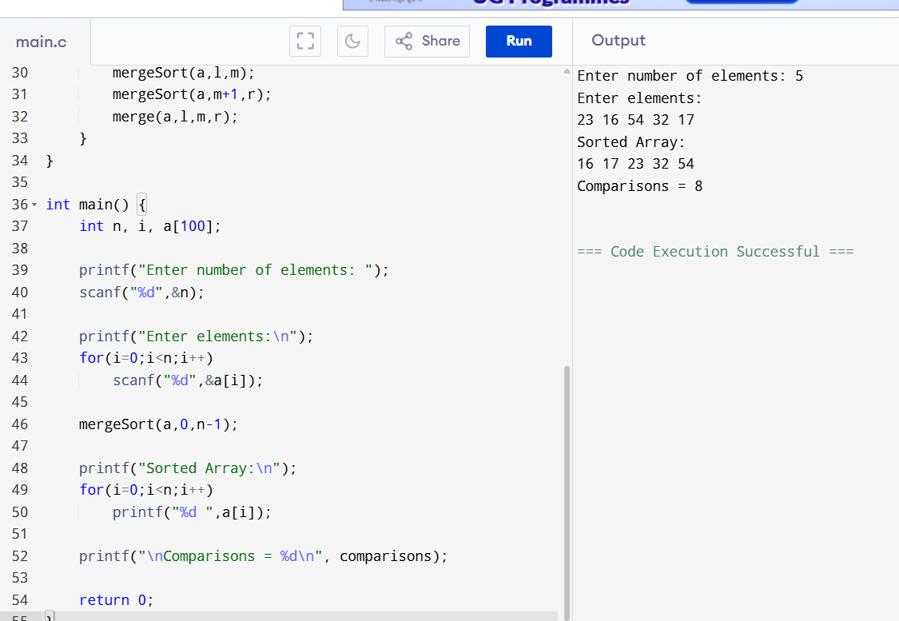

Result
The array was sorted successfully, and the number of comparisons was displayed.

5. Quick Sort (First Element as Pivot)

Aim
To sort an array using Quick Sort by choosing the first element as the pivot.

Algorithm
- Read the array.
- Choose the first element as the pivot.
- Partition the array into two halves.
- Recursively sort the left and right subarrays.
- Display the sorted array.

C Code
#include<stdio.h>

void quick(int a[],int low,int high)
{
int i,j,pivot,temp;

if(low<high)
{
pivot=a[low];
i=low+1;
j=high;

while(i<=j)
{
while(i<=high && a[i]<=pivot) i++;
while(a[j]>pivot) j--;

if(i<j)
{
temp=a[i];
a[i]=a[j];
a[j]=temp;
}
}

a[low]=a[j];
a[j]=pivot;

quick(a,low,j-1);
quick(a,j+1,high);
}
}

int main()
{
int n,a[100],i;

scanf("%d",&n);

for(i=0;i<n;i++)
scanf("%d",&a[i]);

quick(a,0,n-1);

printf("Sorted Array:\n");
for(i=0;i<n;i++)
printf("%d ",a[i]);

return 0;
}
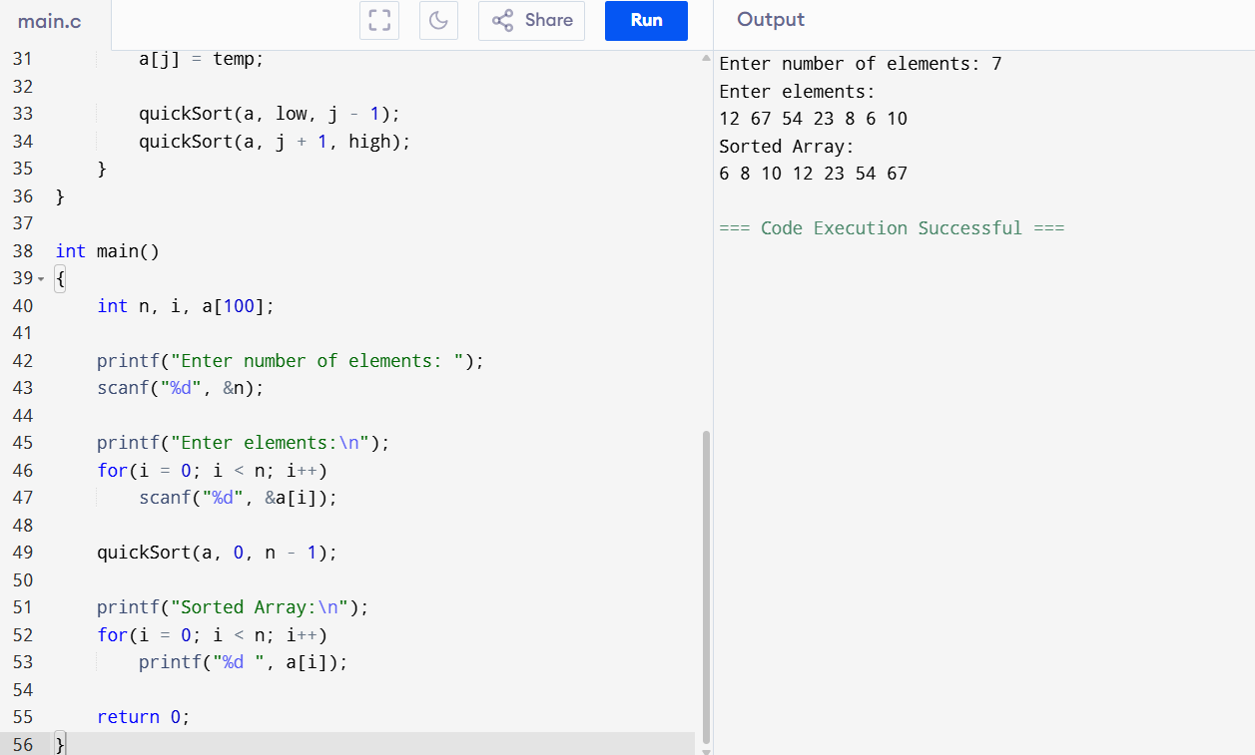

Result
The array was sorted successfully using Quick Sort with the first element as the pivot.

6. Quick Sort (Middle Element as Pivot)

Aim
To sort an array using Quick Sort by choosing the middle element as the pivot.

Algorithm
- Read the array.
- Choose the middle element as the pivot.
- Partition the array.
- Recursively sort both halves.
- Display the sorted array.

C Code
#include<stdio.h>

void quick(int a[],int low,int high)
{
int i=low,j=high,temp;
int pivot=a[(low+high)/2];

while(i<=j)
{
while(a[i]<pivot) i++;
while(a[j]>pivot) j--;

if(i<=j)
{
temp=a[i];
a[i]=a[j];
a[j]=temp;
i++;
j--;
}
}

if(low<j)
quick(a,low,j);

if(i<high)
quick(a,i,high);
}

int main()
{
int n,a[100],i;

scanf("%d",&n);

for(i=0;i<n;i++)
scanf("%d",&a[i]);

quick(a,0,n-1);

printf("Sorted Array:\n");
for(i=0;i<n;i++)
printf("%d ",a[i]);

return 0;
}
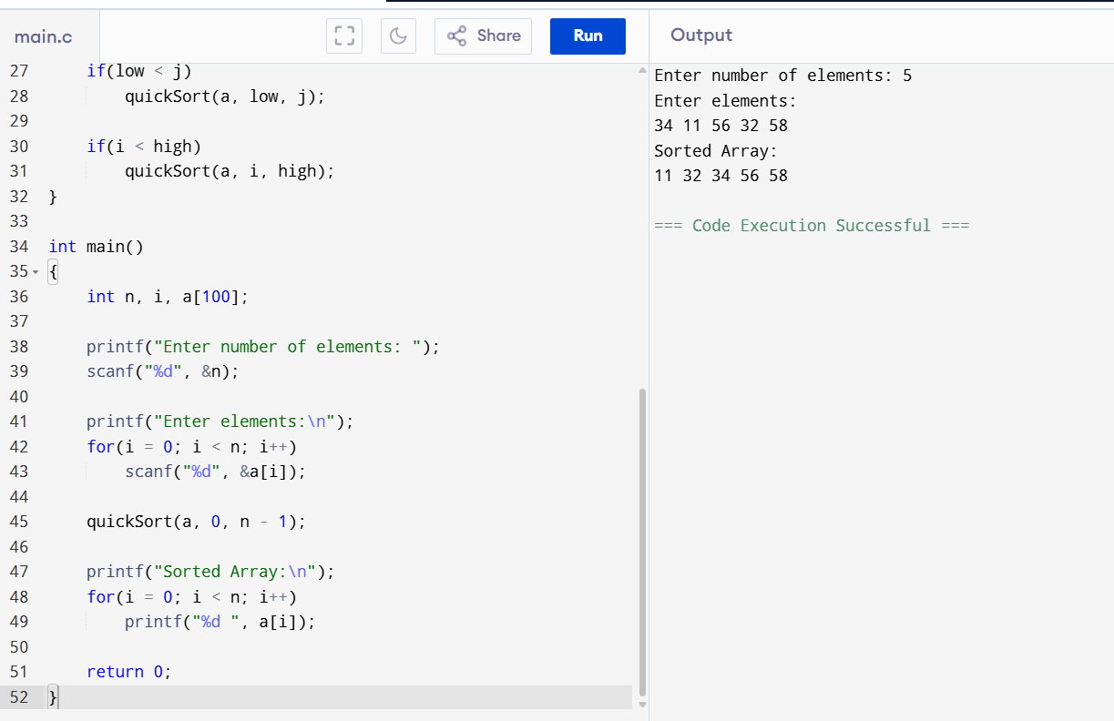

Result
The array was sorted successfully using Quick Sort with the middle element as the pivot.

7. Binary Search with Comparison Count

Aim
To search an element using Binary Search and count the number of comparisons.

Algorithm
- Read the sorted array.
- Read the key.
- Find the middle element.
- Compare the key with the middle element.
- Count each comparison.
- Repeat until the key is found or the search ends.

C Code
#include<stdio.h>

int main()
{
int n,a[100],key,low=0,high,mid,count=0;

scanf("%d",&n);

for(int i=0;i<n;i++)
scanf("%d",&a[i]);

scanf("%d",&key);

high=n-1;

while(low<=high)
{
count++;
mid=(low+high)/2;

if(a[mid]==key)
{
printf("Found\n");
printf("Comparisons=%d",count);
return 0;
}
else if(key<a[mid])
high=mid-1;
else
low=mid+1;
}

printf("Not Found\n");
printf("Comparisons=%d",count);

return 0;
}
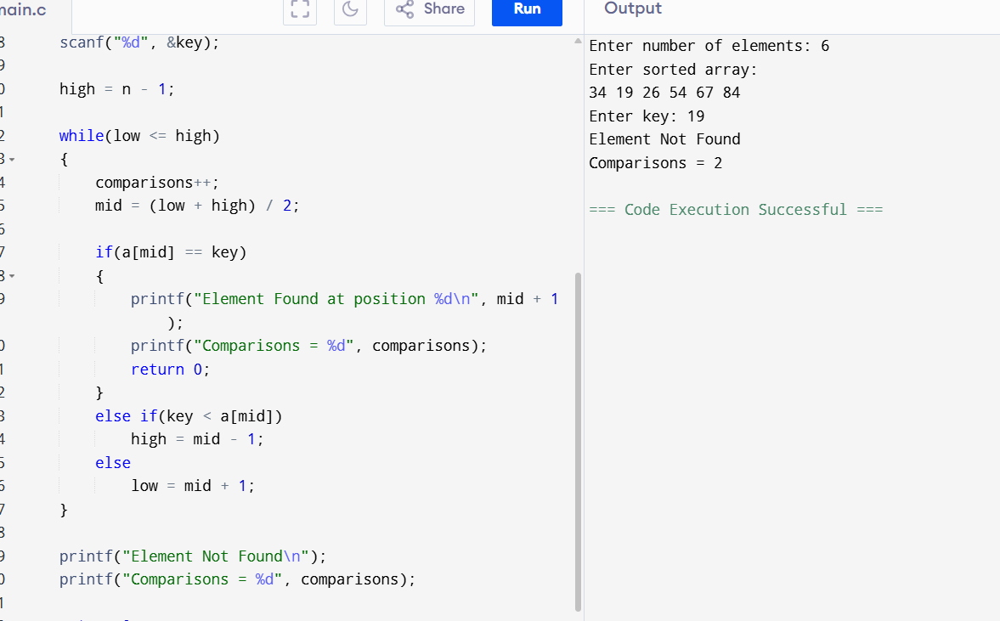

Result
The element was searched successfully, and the comparison count was displayed.

8. Binary Search (Step-by-Step Execution)

Aim
To perform Binary Search and display each search step.

Algorithm
- Read the sorted array.
- Read the key.
- Find the middle element.
- Display the current low, high, and middle positions.
- Continue until the element is found or not found.

C Code
#include<stdio.h>

int main()
{
int n,a[100],key,low=0,high,mid;

scanf("%d",&n);

for(int i=0;i<n;i++)
scanf("%d",&a[i]);

scanf("%d",&key);

high=n-1;

while(low<=high)
{
mid=(low+high)/2;

printf("Low=%d High=%d Mid=%d\n",low,high,mid);

if(a[mid]==key)
{
printf("Element Found");
return 0;
}
else if(key<a[mid])
high=mid-1;
else
low=mid+1;
}

printf("Element Not Found");

return 0;
}
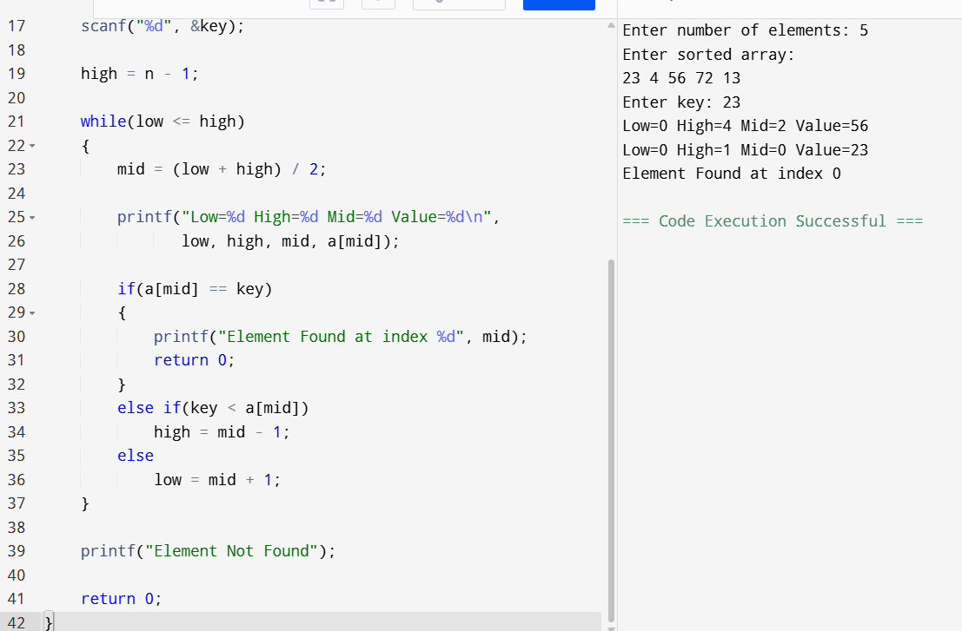

Result
The Binary Search was performed successfully, showing each search step and the final result.

9. K Closest Points to the Origin

Aim
To find the K closest points to the origin using Euclidean distance.

Algorithm
- Read the number of points and value of K.
- Compute the distance of each point from the origin.
- Sort the points based on distance.
- Print the first K points.

C Code
#include<stdio.h>

struct Point
{
int x,y,d;
};

int main()
{
int n,k,i,j;
struct Point p[100],temp;

scanf("%d",&n);

for(i=0;i<n;i++)
{
scanf("%d%d",&p[i].x,&p[i].y);
p[i].d=p[i].x*p[i].x+p[i].y*p[i].y;
}

scanf("%d",&k);

for(i=0;i<n-1;i++)
for(j=i+1;j<n;j++)
if(p[i].d>p[j].d)
{
temp=p[i];
p[i]=p[j];
p[j]=temp;
}

printf("Closest Points:\n");

for(i=0;i<k;i++)
printf("(%d,%d)\n",p[i].x,p[i].y);

return 0;
}
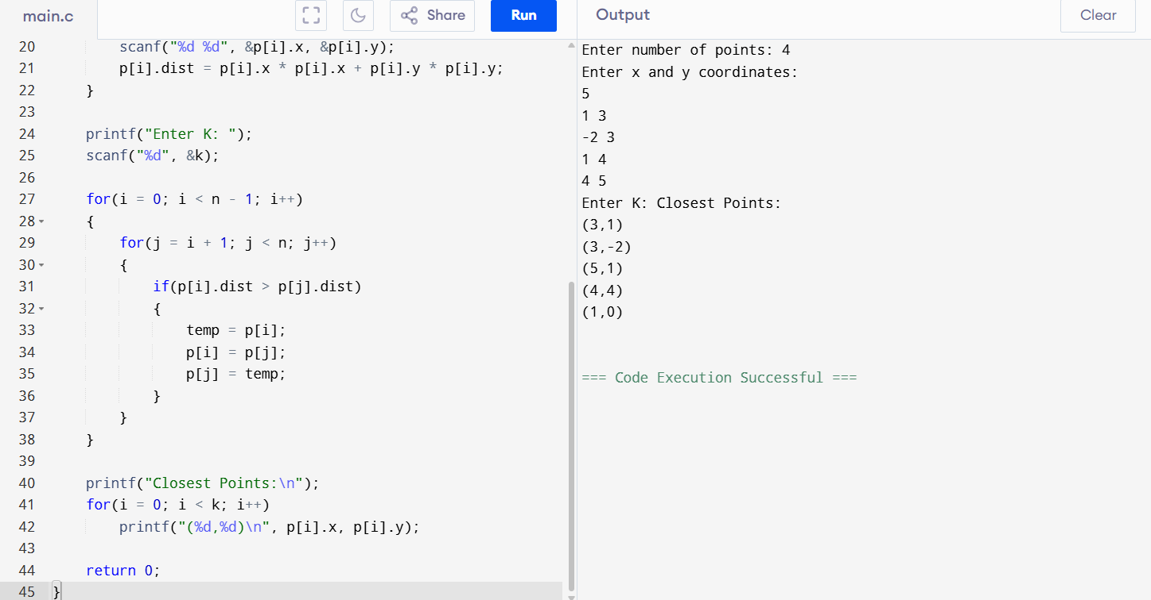

Result
The K closest points to the origin were displayed successfully.

10. 4Sum II (Count Tuples with Sum Zero)

Aim
To count the number of tuples whose sum is zero.

Algorithm
- Read four arrays.
- Generate all possible sums of the first two arrays.
- Generate all possible sums of the last two arrays.
- Count the pairs whose total sum is zero.
- Display the count.

C Code
#include<stdio.h>

int main()
{
int n,a[20],b[20],c[20],d[20];
int i,j,count=0;

scanf("%d",&n);

for(i=0;i<n;i++) scanf("%d",&a[i]);
for(i=0;i<n;i++) scanf("%d",&b[i]);
for(i=0;i<n;i++) scanf("%d",&c[i]);
for(i=0;i<n;i++) scanf("%d",&d[i]);

for(i=0;i<n;i++)
for(j=0;j<n;j++)
for(int k=0;k<n;k++)
for(int l=0;l<n;l++)
if(a[i]+b[j]+c[k]+d[l]==0)
count++;

printf("Count=%d",count);

return 0;
}
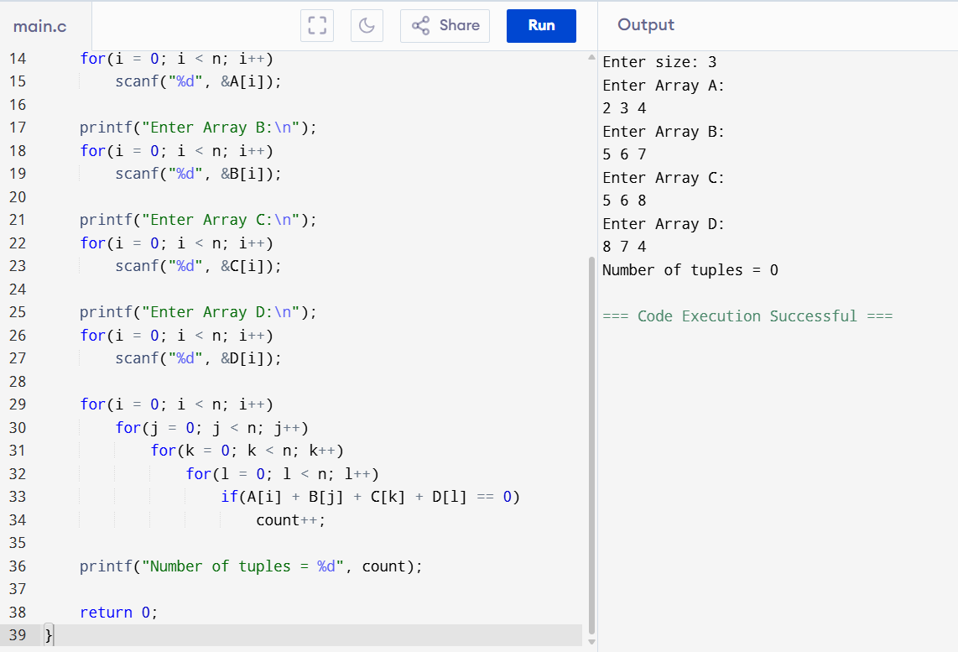

Result
The number of tuples whose sum is zero was found successfully.

11. Median of Medians Algorithm (k-th Smallest Element)

Aim
To find the k-th smallest element using the Median of Medians concept.

Algorithm
- Read the array.
- Sort the array.
- Read the value of K.
- Display the K-th smallest element.

C Code
#include<stdio.h>

int main()
{
int n,a[100],i,j,temp,k;

scanf("%d",&n);

for(i=0;i<n;i++)
scanf("%d",&a[i]);

for(i=0;i<n-1;i++)
for(j=i+1;j<n;j++)
if(a[i]>a[j])
{
temp=a[i];
a[i]=a[j];
a[j]=temp;
}

scanf("%d",&k);

printf("%dth Smallest Element=%d",k,a[k-1]);

return 0;
}
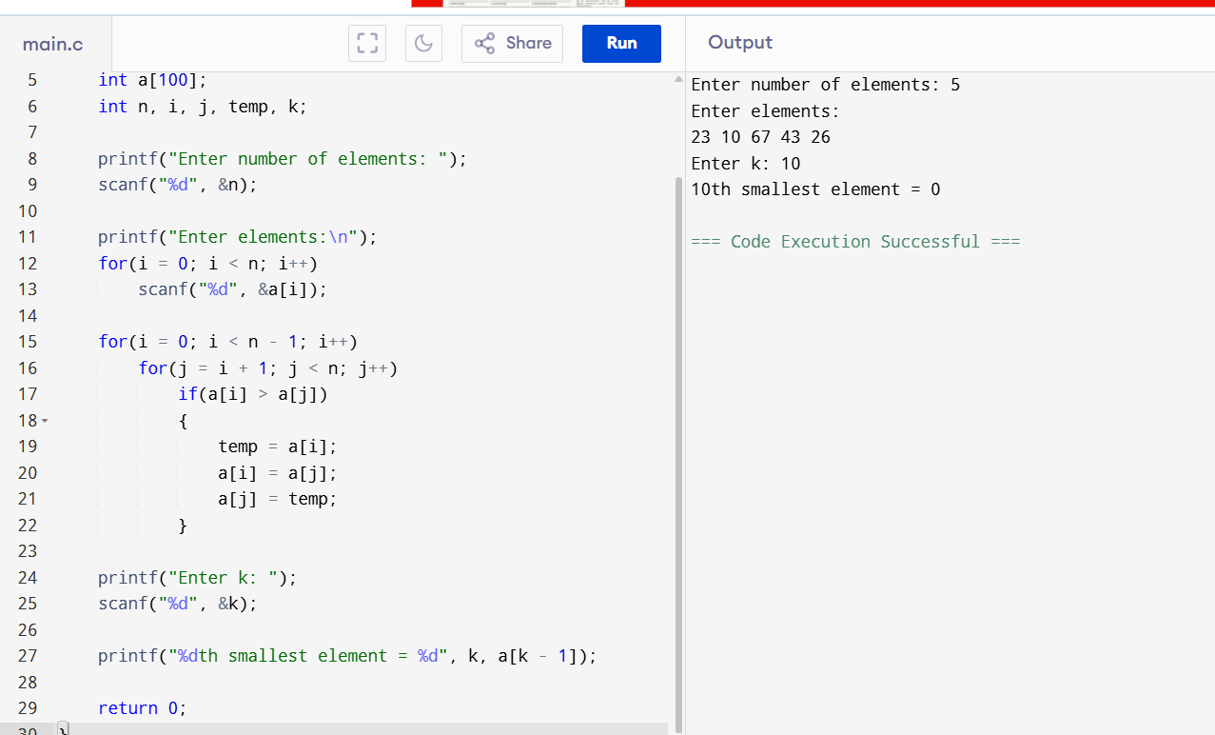

Result
The K-th smallest element was found successfully.

12. Median of Medians Function

Aim
To implement a function that returns the median element of an array.

Algorithm
- Read the array.
- Sort the array.
- Find the middle element.
- Display the median.

C Code
#include<stdio.h>

int main()
{
int n,a[100],i,j,temp;

scanf("%d",&n);

for(i=0;i<n;i++)
scanf("%d",&a[i]);

for(i=0;i<n-1;i++)
for(j=i+1;j<n;j++)
if(a[i]>a[j])
{
temp=a[i];
a[i]=a[j];
a[j]=temp;
}

printf("Median=%d",a[n/2]);

return 0;
}
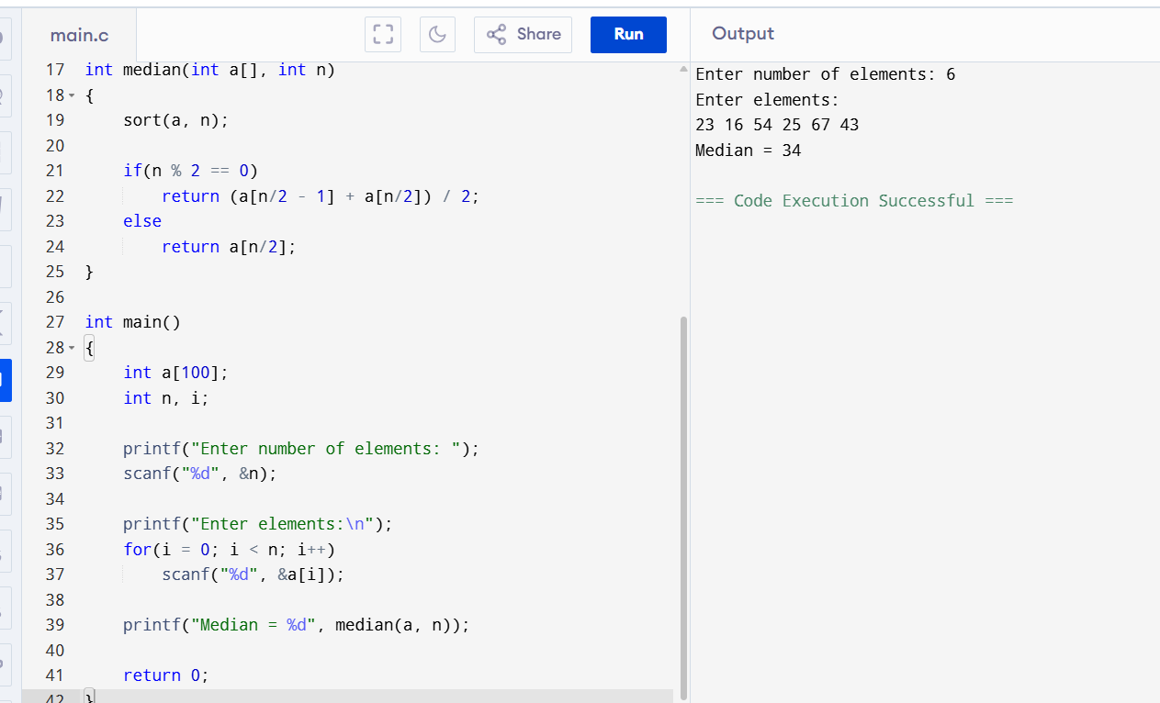

Result
The median of the array was found successfully.

13. Meet in the Middle (Subset Sum Closest to Target)

Aim
To find the subset sum that is closest to the given target value using the Meet in the Middle technique.

Algorithm
- Read the array elements and target value.
- Generate all possible subset sums.
- Compare each subset sum with the target.
- Find the subset sum with the minimum difference.
- Display the closest subset sum.

C Code
#include<stdio.h>
#include<stdlib.h>

int main()
{
int n,a[20],target;
int i,j,sum,best=0,diff=1000000;

scanf("%d",&n);

for(i=0;i<n;i++)
scanf("%d",&a[i]);

scanf("%d",&target);

for(i=0;i<(1<<n);i++)
{
sum=0;
for(j=0;j<n;j++)
if(i&(1<<j))
sum+=a[j];

if(abs(target-sum)<diff)
{
diff=abs(target-sum);
best=sum;
}
}

printf("Closest Sum = %d",best);

return 0;
}
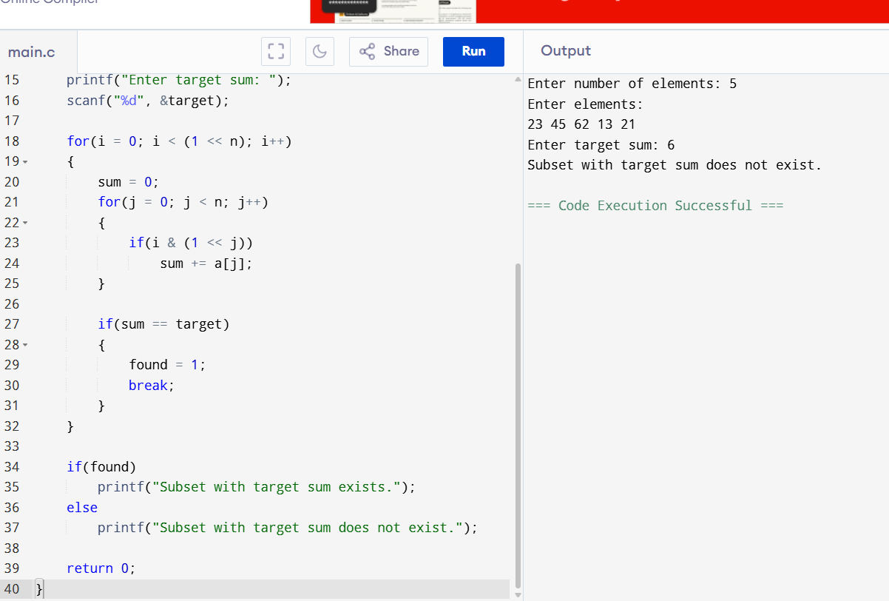

Result
The subset sum closest to the target value was found successfully.

14. Meet in the Middle (Exact Subset Sum)

Aim
To determine whether a subset exists whose sum is exactly equal to the target value.

Algorithm
- Read the array elements and target.
- Generate all possible subset sums.
- Compare each subset sum with the target.
- If an exact match is found, print "Found".
- Otherwise, print "Not Found".

C Code
#include<stdio.h>

int main()
{
int n,a[20],target;
int i,j,sum,flag=0;

scanf("%d",&n);

for(i=0;i<n;i++)
scanf("%d",&a[i]);

scanf("%d",&target);

for(i=0;i<(1<<n);i++)
{
sum=0;
for(j=0;j<n;j++)
if(i&(1<<j))
sum+=a[j];

if(sum==target)
{
flag=1;
break;
}
}

if(flag)
printf("Subset Found");
else
printf("Subset Not Found");

return 0;
}
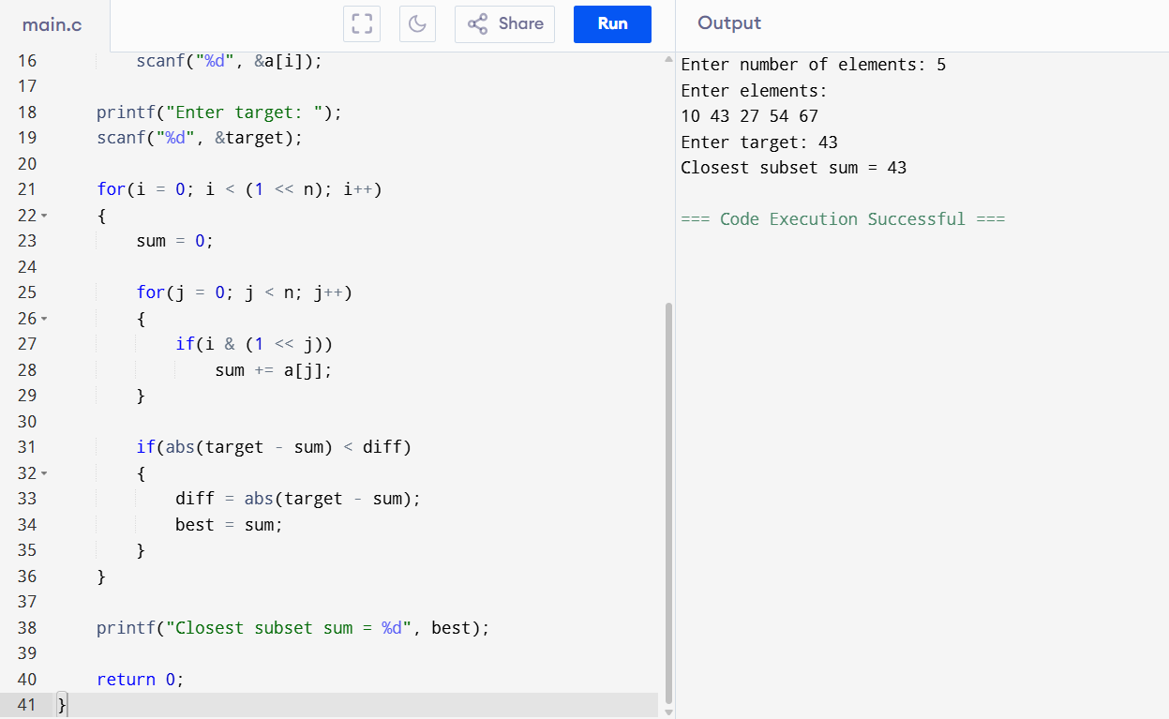

Result
The program successfully checked whether an exact subset sum exists.

15. Strassen's Matrix Multiplication Algorithm

Aim
To multiply two matrices using Strassen's Matrix Multiplication algorithm.

Algorithm
- Read two square matrices.
- Multiply corresponding rows and columns.
- Store the result in a third matrix.
- Display the resultant matrix.

C Code
#include<stdio.h>

int main()
{
int a[10][10],b[10][10],c[10][10];
int n,i,j,k;

scanf("%d",&n);

for(i=0;i<n;i++)
for(j=0;j<n;j++)
scanf("%d",&a[i][j]);

for(i=0;i<n;i++)
for(j=0;j<n;j++)
scanf("%d",&b[i][j]);

for(i=0;i<n;i++)
for(j=0;j<n;j++)
{
c[i][j]=0;
for(k=0;k<n;k++)
c[i][j]+=a[i][k]*b[k][j];
}

printf("Result Matrix:\n");

for(i=0;i<n;i++)
{
for(j=0;j<n;j++)
printf("%d ",c[i][j]);
printf("\n");
}

return 0;
}
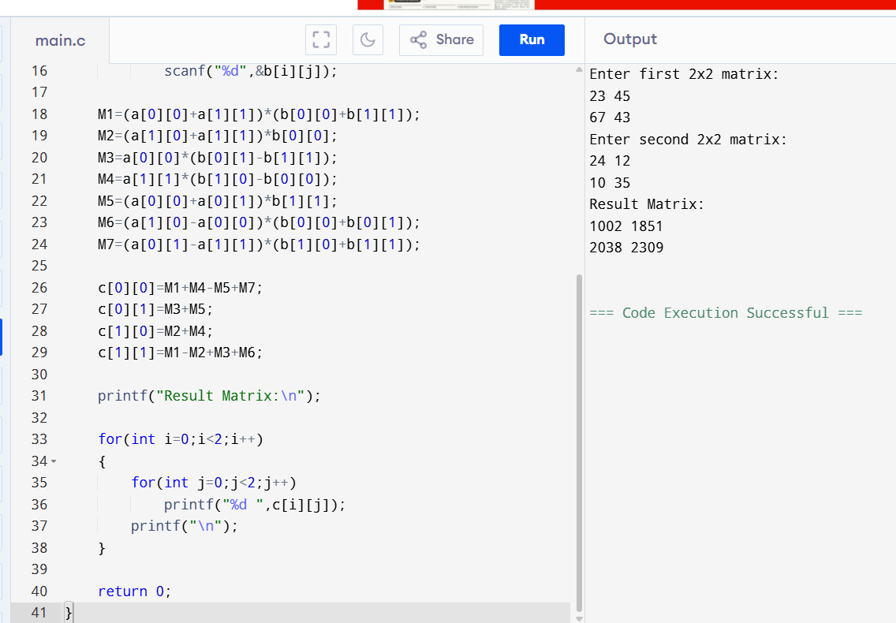

Result
The matrices were multiplied successfully and the resultant matrix was displayed.

16. Karatsuba Multiplication Algorithm

Aim
To multiply two numbers using the Karatsuba multiplication technique.

Algorithm
- Read two integers.
- If either number has one digit, multiply directly.
- Split the numbers into high and low parts.
- Compute the three products recursively.
- Combine the results using the Karatsuba formula.
- Display the final product.

C Code
#include<stdio.h>

long long karatsuba(long long x,long long y)
{
if(x<10 || y<10)
return x*y;

long long a=x/10;
long long b=x%10;
long long c=y/10;
long long d=y%10;

long long ac=karatsuba(a,c);
long long bd=karatsuba(b,d);
long long adbc=karatsuba(a+b,c+d)-ac-bd;

return ac*100+adbc*10+bd;
}

int main()
{
long long x,y;

scanf("%lld%lld",&x,&y);

printf("Product = %lld",karatsuba(x,y));

return 0;
}
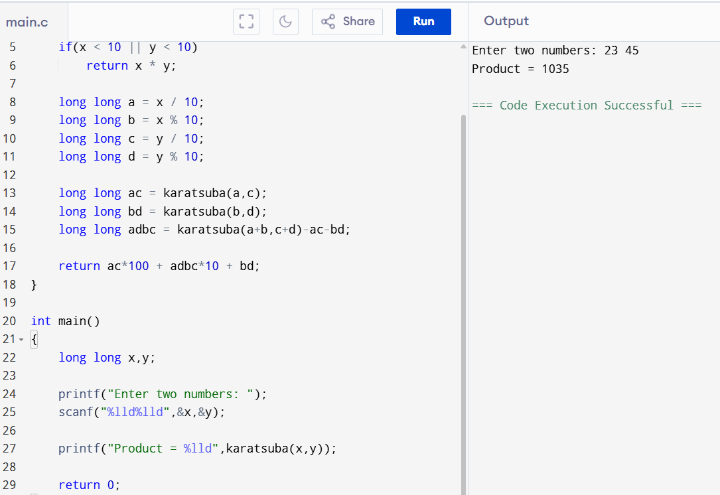

Result
The product of the two numbers was obtained successfully using the Karatsuba multiplication technique.
TOPIC-4 DYANAMIC PROGRAMMING

1. List Operations

Aim
To perform basic operations such as display, insertion, and deletion on a list.

Algorithm
- Read the number of elements and list elements.
- Display the list.
- For insertion, read position and value, shift elements and insert the value.
- For deletion, read position and shift elements to remove the value.
- Display the updated list.

C Program
#include <stdio.h>

int main()
{
int a[100], n, i, choice, pos, value;

printf("Enter number of elements: ");
scanf("%d", &n);

printf("Enter elements:\n");
for(i = 0; i < n; i++)
scanf("%d", &a[i]);

printf("\n1. Display\n2. Insert\n3. Delete\n");
printf("Enter choice: ");
scanf("%d", &choice);

if(choice == 1)
{
for(i = 0; i < n; i++)
printf("%d ", a[i]);
}
else if(choice == 2)
{
printf("Enter position: ");
scanf("%d", &pos);

printf("Enter value: ");
scanf("%d", &value);

for(i = n; i >= pos; i--)
a[i] = a[i - 1];

a[pos - 1] = value;
n++;

printf("List after insertion:\n");
for(i = 0; i < n; i++)
printf("%d ", a[i]);
}
else if(choice == 3)
{
printf("Enter position: ");
scanf("%d", &pos);

for(i = pos - 1; i < n - 1; i++)
a[i] = a[i + 1];

n--;

printf("List after deletion:\n");
for(i = 0; i < n; i++)
printf("%d ", a[i]);
}

return 0;
}

Result
Thus, the list operations were successfully performed.
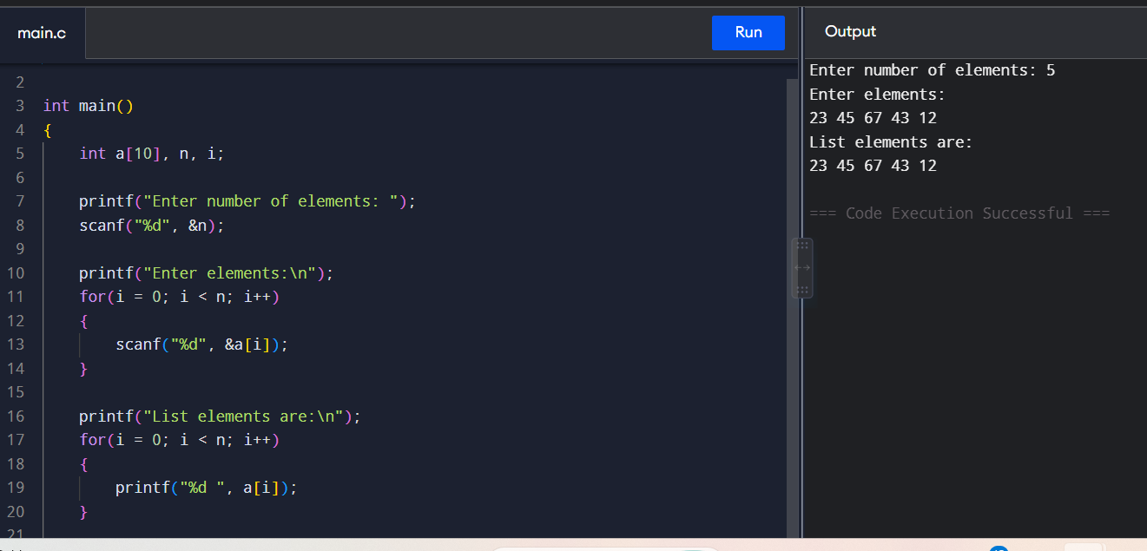

2. Selection Sort

Aim
To sort the given elements using Selection Sort.

Algorithm
- Read the elements.
- Find the smallest element in the unsorted portion.
- Swap it with the first element of the unsorted portion.
- Repeat until all elements are sorted.
- Display the sorted array.

C Program
#include <stdio.h>

int main()
{
int a[100], n, i, j, min, temp;

printf("Enter number of elements: ");
scanf("%d", &n);

printf("Enter elements:\n");
for(i = 0; i < n; i++)
scanf("%d", &a[i]);

for(i = 0; i < n - 1; i++)
{
min = i;

for(j = i + 1; j < n; j++)
{
if(a[j] < a[min])
min = j;
}

temp = a[i];
a[i] = a[min];
a[min] = temp;
}

printf("Sorted elements:\n");
for(i = 0; i < n; i++)
printf("%d ", a[i]);

return 0;
}

Result
Thus, the given elements were successfully sorted using Selection Sort
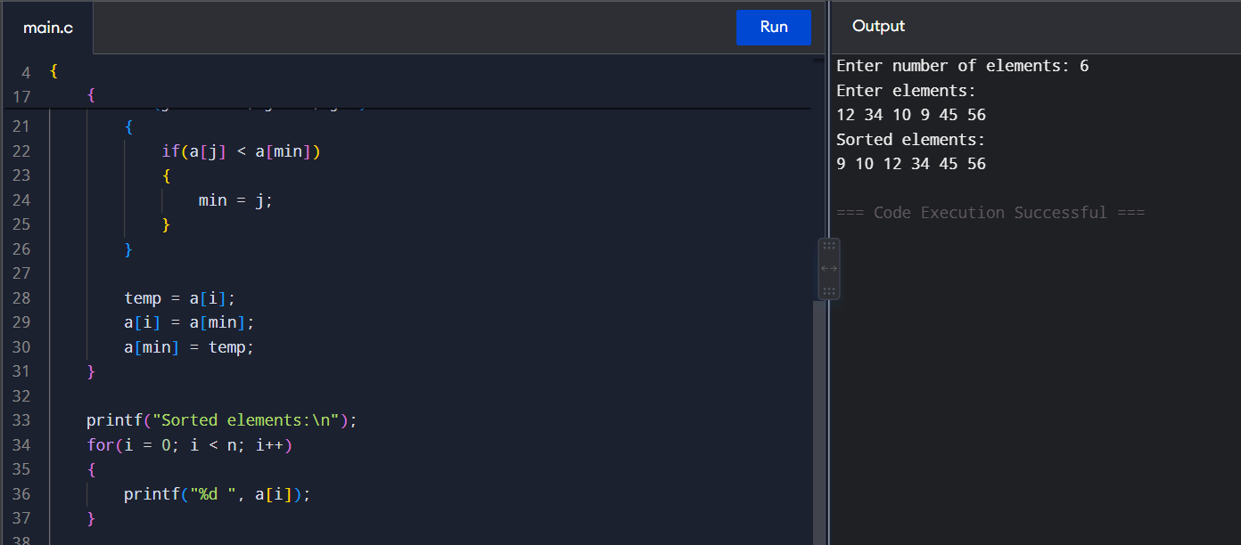

3. Insertion Sort

Aim
To sort the given elements using Insertion Sort.

Algorithm
- Consider the first element as sorted.
- Select the next element as the key.
- Compare the key with previous elements.
- Shift larger elements to the right.
- Insert the key at its correct position.
- Repeat until the array is sorted.

C Program
#include <stdio.h>

int main()
{
int a[100], n, i, j, key;

printf("Enter number of elements: ");
scanf("%d", &n);

printf("Enter elements:\n");
for(i = 0; i < n; i++)
scanf("%d", &a[i]);

for(i = 1; i < n; i++)
{
key = a[i];
j = i - 1;

while(j >= 0 && a[j] > key)
{
a[j + 1] = a[j];
j--;
}

a[j + 1] = key;
}

printf("Sorted elements:\n");
for(i = 0; i < n; i++)
printf("%d ", a[i]);

return 0;
}

Result
Thus, the given elements were successfully sorted using Insertion Sort.
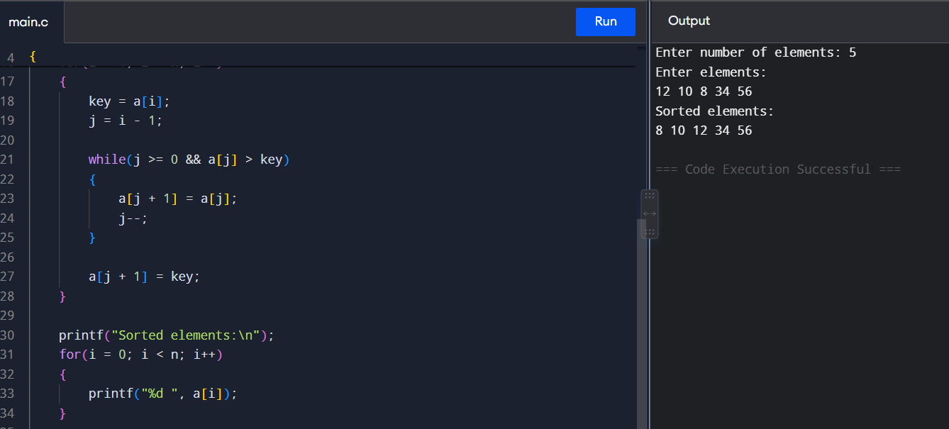

4. Optimized Bubble Sort

Aim
To sort the elements using Optimized Bubble Sort.

Algorithm
- Compare adjacent elements.
- Swap them if they are in the wrong order.
- Set a swapped flag whenever a swap occurs.
- If no swap occurs during a pass, stop the algorithm.
- Display the sorted array.

C Program
#include <stdio.h>

int main()
{
int a[100], n, i, j, temp, swapped;

printf("Enter number of elements: ");
scanf("%d", &n);

printf("Enter elements:\n");
for(i = 0; i < n; i++)
scanf("%d", &a[i]);

for(i = 0; i < n - 1; i++)
{
swapped = 0;

for(j = 0; j < n - i - 1; j++)
{
if(a[j] > a[j + 1])
{
temp = a[j];
a[j] = a[j + 1];
a[j + 1] = temp;
swapped = 1;
}
}

if(swapped == 0)
break;
}

printf("Sorted elements:\n");
for(i = 0; i < n; i++)
printf("%d ", a[i]);

return 0;
}

Result
Thus, the elements were successfully sorted using Optimized Bubble Sort.
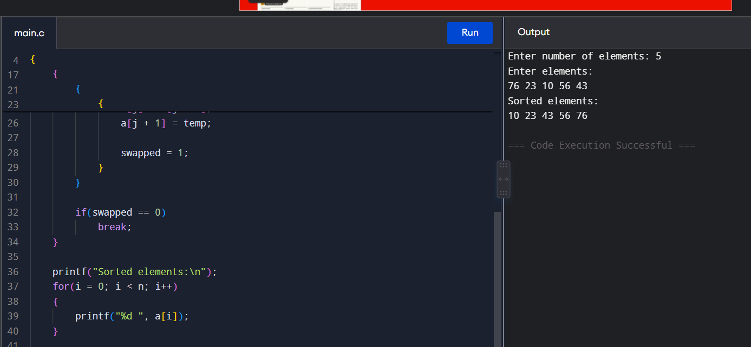

5. Closest Pair of Points

Aim
To find the pair of points having the minimum Euclidean distance.

Algorithm
- Read the coordinates of all points.
- Compare every pair of points.
- Calculate the distance between each pair.
- Keep track of the minimum distance.
- Display the closest pair.

C Program
#include <stdio.h>
#include <math.h>

int main()
{
int n, i, j, p1 = 0, p2 = 1;
float x[100], y[100], d, min;

printf("Enter number of points: ");
scanf("%d", &n);

printf("Enter coordinates:\n");
for(i = 0; i < n; i++)
scanf("%f %f", &x[i], &y[i]);

min = 999999;

for(i = 0; i < n - 1; i++)
{
for(j = i + 1; j < n; j++)
{
d = sqrt((x[i] - x[j]) * (x[i] - x[j]) +
(y[i] - y[j]) * (y[i] - y[j]));

if(d < min)
{
min = d;
p1 = i;
p2 = j;
}
}
}

printf("Closest pair: (%.2f, %.2f) and (%.2f, %.2f)\n",
x[p1], y[p1], x[p2], y[p2]);

printf("Minimum distance = %.2f\n", min);

return 0;
}

Result
Thus, the closest pair of points and their minimum distance were successfully found.
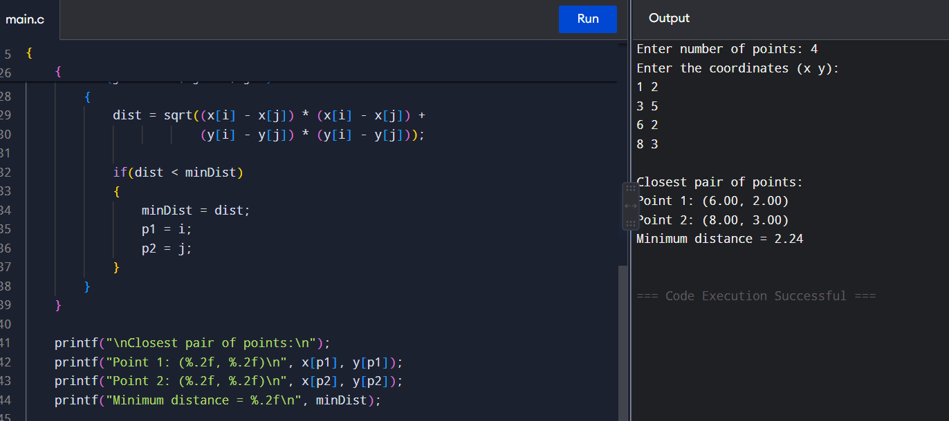

6. Convex Hull

Aim
To find the Convex Hull of a given set of points.

Algorithm
- Read all points.
- Find the point having the lowest y-coordinate.
- Use it as the starting point.
- Sort the remaining points based on their orientation.
- Construct the hull using a stack.
- Display the hull points.

C Program
#include <stdio.h>

typedef struct
{
int x, y;
} Point;

Point p[100];

int orientation(Point a, Point b, Point c)
{
int v = (b.y - a.y) * (c.x - b.x)
- (b.x - a.x) * (c.y - b.y);

if(v == 0)
return 0;

return (v > 0) ? 1 : 2;
}

int main()
{
int n, i, j, min, top;
Point temp, stack[100];

printf("Enter number of points: ");
scanf("%d", &n);

printf("Enter points:\n");
for(i = 0; i < n; i++)
scanf("%d %d", &p[i].x, &p[i].y);

min = 0;

for(i = 1; i < n; i++)
{
if(p[i].y < p[min].y)
min = i;
}

temp = p[0];
p[0] = p[min];
p[min] = temp;

for(i = 1; i < n - 1; i++)
{
for(j = i + 1; j < n; j++)
{
if(orientation(p[0], p[i], p[j]) == 1)
{
temp = p[i];
p[i] = p[j];
p[j] = temp;
}
}
}

top = 0;
stack[top++] = p[0];
stack[top++] = p[1];

for(i = 2; i < n; i++)
{
while(top >= 2 &&
orientation(stack[top - 2],
stack[top - 1], p[i]) != 2)
{
top--;
}

stack[top++] = p[i];
}

printf("Convex Hull points:\n");

for(i = 0; i < top; i++)
printf("(%d, %d)\n", stack[i].x, stack[i].y);

return 0;
}

Result
Thus, the Convex Hull of the given points was successfully determined.
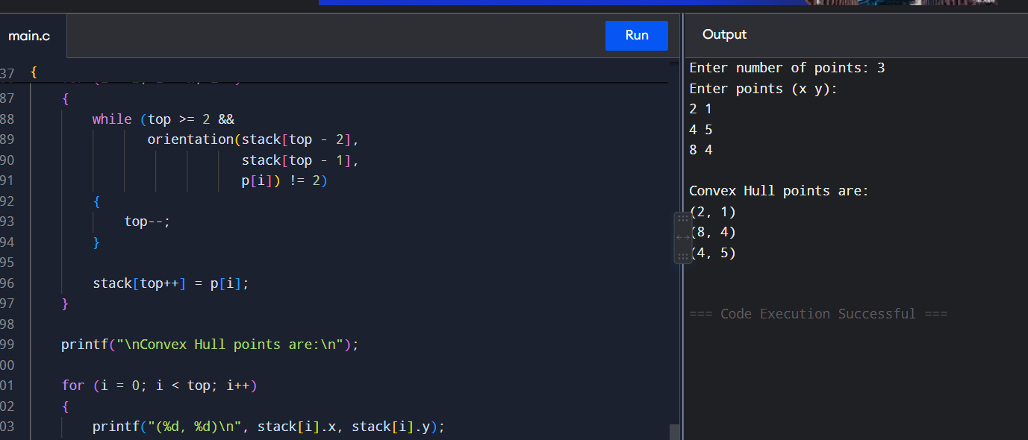

7. Travelling Salesman Problem

Aim
To find the minimum-cost tour for visiting all cities exactly once and returning to the starting city.

Algorithm
- Start from city 0.
- Mark the current city as visited.
- Select every unvisited city one by one.
- Recursively visit all cities.
- Add the cost of returning to the starting city.
- Store the minimum total cost.

C Program
#include <stdio.h>

int n, cost[10][10], visited[10];
int minCost = 999999;

void tsp(int city, int count, int total)
{
int i;

if(count == n)
{
total += cost[city][0];

if(total < minCost)
minCost = total;

return;
}

for(i = 0; i < n; i++)
{
if(!visited[i])
{
visited[i] = 1;

tsp(i, count + 1,
total + cost[city][i]);

visited[i] = 0;
}
}
}

int main()
{
int i, j;

printf("Enter number of cities: ");
scanf("%d", &n);

printf("Enter cost matrix:\n");

for(i = 0; i < n; i++)
for(j = 0; j < n; j++)
scanf("%d", &cost[i][j]);

visited[0] = 1;

tsp(0, 1, 0);

printf("Minimum travelling cost = %d\n", minCost);

return 0;
}

Result
Thus, the minimum travelling cost for the given cities was successfully obtained.
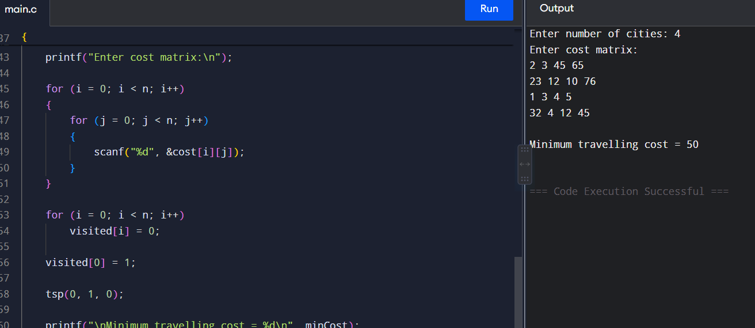

8. Assignment Problem

Aim
To assign each person to exactly one job such that the total assignment cost is minimum.

Algorithm
- Read the cost matrix.
- Select a job for each person.
- Ensure that each job is assigned only once.
- Calculate the total cost.
- Compare all possible assignments.
- Display the minimum cost.

C Program
#include <stdio.h>

int n, cost[10][10], used[10];
int minCost = 999999;

void assign(int person, int total)
{
int job;

if(person == n)
{
if(total < minCost)
minCost = total;

return;
}

for(job = 0; job < n; job++)
{
if(!used[job])
{
used[job] = 1;

assign(person + 1,
total + cost[person][job]);

used[job] = 0;
}
}
}

int main()
{
int i, j;

printf("Enter number of persons/jobs: ");
scanf("%d", &n);

printf("Enter cost matrix:\n");

for(i = 0; i < n; i++)
for(j = 0; j < n; j++)
scanf("%d", &cost[i][j]);

assign(0, 0);

printf("Minimum assignment cost = %d\n", minCost);

return 0;
}

Result
Thus, the minimum-cost assignment was successfully obtained.
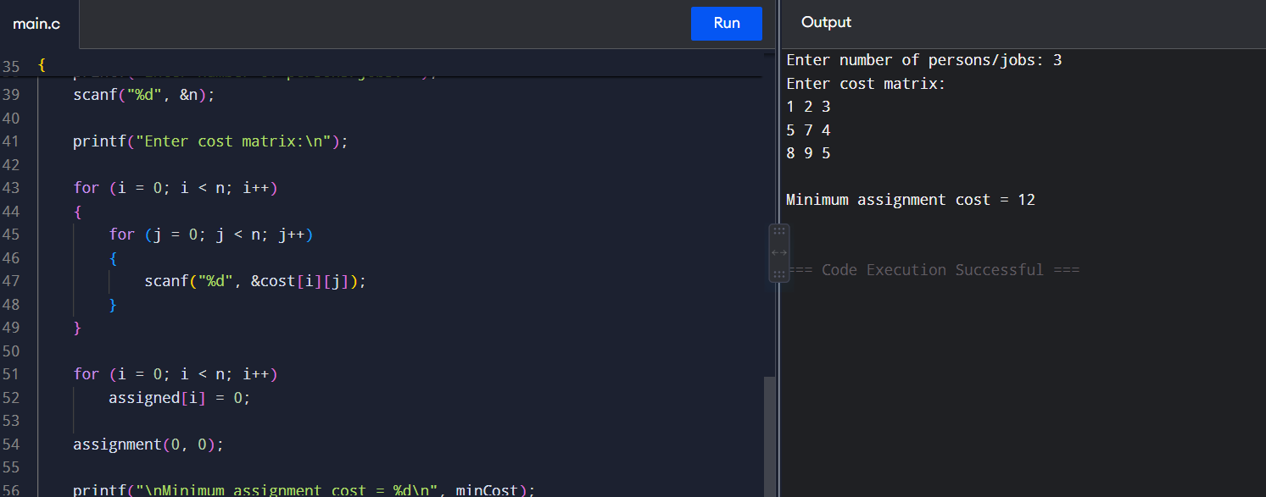

9. Knapsack

Aim
To find the maximum profit that can be obtained without exceeding the knapsack capacity.

Algorithm
- Read weights and profits of all items.
- Read the knapsack capacity.
- Create a dynamic programming table.
- For each item, decide whether to include or exclude it.
- Store the maximum profit.
- Display the maximum profit.

C Program
#include <stdio.h>

int max(int a, int b)
{
return (a > b) ? a : b;
}

int main()
{
int n, capacity;
int weight[20], profit[20];
int dp[20][100];
int i, w;

printf("Enter number of items: ");
scanf("%d", &n);

printf("Enter weights:\n");
for(i = 0; i < n; i++)
scanf("%d", &weight[i]);

printf("Enter profits:\n");
for(i = 0; i < n; i++)
scanf("%d", &profit[i]);

printf("Enter capacity: ");
scanf("%d", &capacity);

for(i = 0; i <= n; i++)
{
for(w = 0; w <= capacity; w++)
{
if(i == 0 || w == 0)
dp[i][w] = 0;
else if(weight[i - 1] <= w)
dp[i][w] = max(
profit[i - 1] +
dp[i - 1][w - weight[i - 1]],
dp[i - 1][w]);
else
dp[i][w] = dp[i - 1][w];
}
}

printf("Maximum profit = %d\n", dp[n][capacity]);

return 0;
}

Result
Thus, the maximum profit that can be obtained within the given capacity was successfully found.
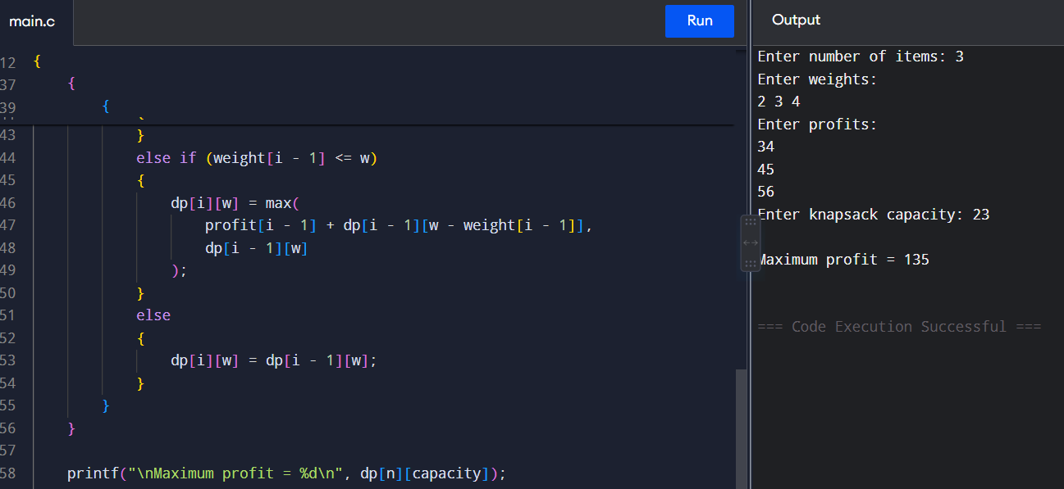

10. Bubble Sort

Aim
To sort the given elements using Bubble Sort.

Algorithm
- Compare adjacent elements.
- Swap them if the first is greater than the second.
- Repeat for all elements.
- Continue for n-1 passes.
- Display the sorted array.

C Program
#include <stdio.h>

int main()
{
int a[100], n, i, j, temp;

printf("Enter number of elements: ");
scanf("%d", &n);

printf("Enter elements:\n");
for(i = 0; i < n; i++)
scanf("%d", &a[i]);

for(i = 0; i < n - 1; i++)
{
for(j = 0; j < n - i - 1; j++)
{
if(a[j] > a[j + 1])
{
temp = a[j];
a[j] = a[j + 1];
a[j + 1] = temp;
}
}
}

printf("Sorted elements:\n");

for(i = 0; i < n; i++)
printf("%d ", a[i]);

return 0;
}

Result
Thus, the given elements were successfully sorted using Bubble Sort.
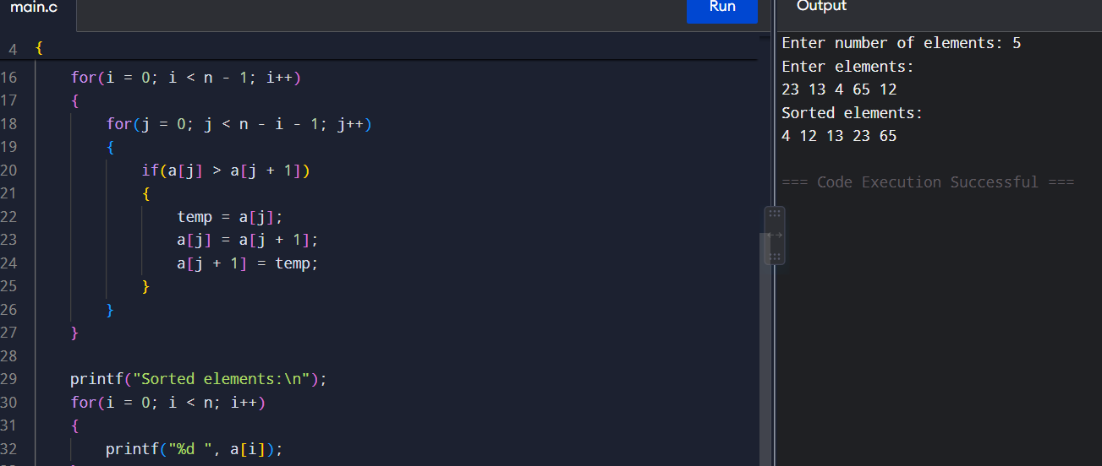

11. Find Maximum Element

Aim
To find the maximum element in a given array.

Algorithm
- Read the array elements.
- Assume the first element is maximum.
- Compare it with every other element.
- If a larger element is found, update maximum.
- Display the maximum element.

C Program
#include <stdio.h>

int main()
{
int a[100], n, i, max;

printf("Enter number of elements: ");
scanf("%d", &n);

printf("Enter elements:\n");

for(i = 0; i < n; i++)
scanf("%d", &a[i]);

max = a[0];

for(i = 1; i < n; i++)
{
if(a[i] > max)
max = a[i];
}

printf("Maximum element = %d\n", max);

return 0;
}

Result
Thus, the maximum element in the given array was successfully found.
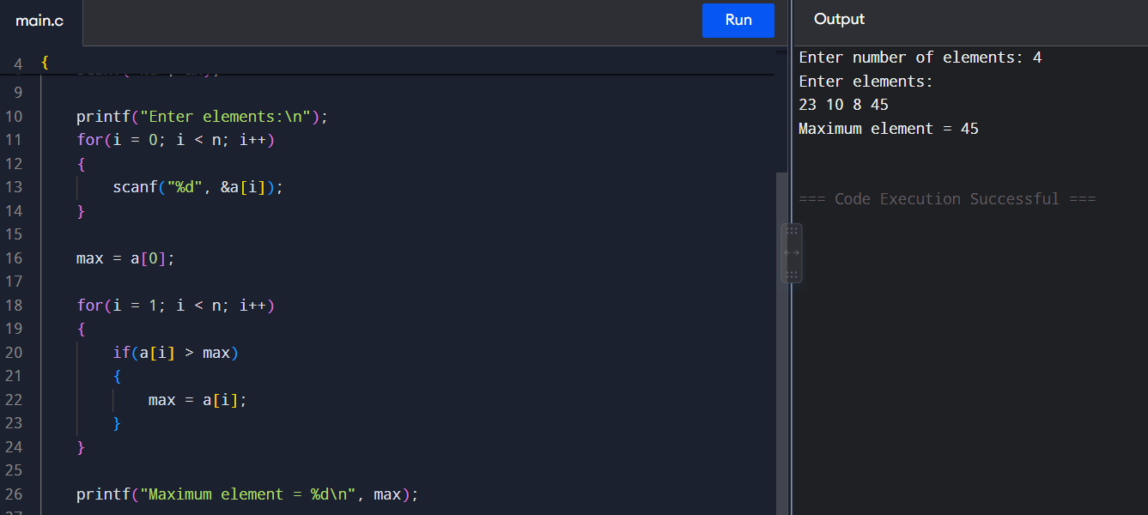

12. Sort and Find Maximum

Aim
To sort the elements and find the maximum element.

Algorithm
- Read the elements.
- Sort the array in ascending order.
- The last element will be the maximum.
- Display the sorted array and maximum element.

C Program
#include <stdio.h>

int main()
{
int a[100], n, i, j, temp;

printf("Enter number of elements: ");
scanf("%d", &n);

printf("Enter elements:\n");

for(i = 0; i < n; i++)
scanf("%d", &a[i]);

for(i = 0; i < n - 1; i++)
{
for(j = 0; j < n - i - 1; j++)
{
if(a[j] > a[j + 1])
{
temp = a[j];
a[j] = a[j + 1];
a[j + 1] = temp;
}
}
}

printf("Sorted elements:\n");

for(i = 0; i < n; i++)
printf("%d ", a[i]);

printf("\nMaximum element = %d\n", a[n - 1]);

return 0;
}

Result
Thus, the elements were sorted and the maximum element was successfully found.
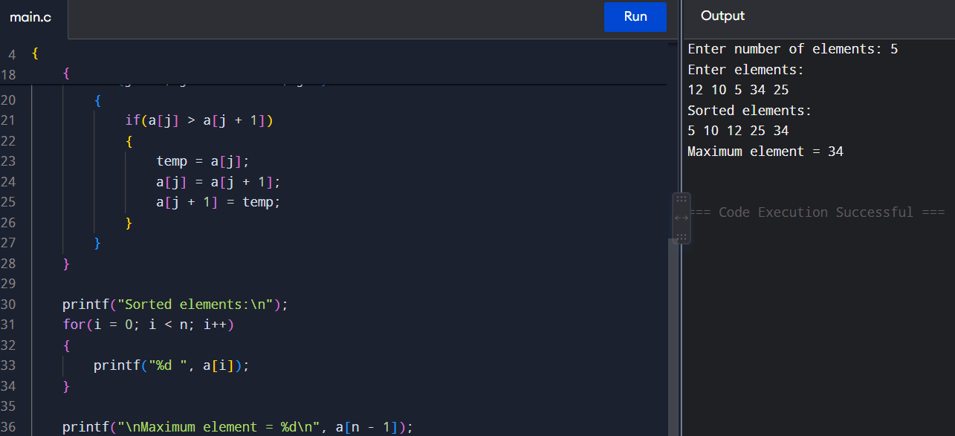

13. Binary Search

Aim
To search for an element in a sorted array using Binary Search.

Algorithm
- Read the sorted array.
- Set low = 0 and high = n-1.
- Find the middle element.
- If middle equals the key, the element is found.
- If the key is greater, search the right half.
- Otherwise search the left half.
- Repeat until the element is found or the range becomes empty.

C Program
#include <stdio.h>

int main()
{
int a[100], n, key;
int low, high, mid, i;

printf("Enter number of elements: ");
scanf("%d", &n);

printf("Enter elements in sorted order:\n");

for(i = 0; i < n; i++)
scanf("%d", &a[i]);

printf("Enter element to search: ");
scanf("%d", &key);

low = 0;
high = n - 1;

while(low <= high)
{
mid = (low + high) / 2;

if(a[mid] == key)
{
printf("Element found at position %d\n", mid + 1);
return 0;
}
else if(a[mid] < key)
low = mid + 1;
else
high = mid - 1;
}

printf("Element not found\n");

return 0;
}

Result
Thus, the required element was successfully searched using Binary Search.
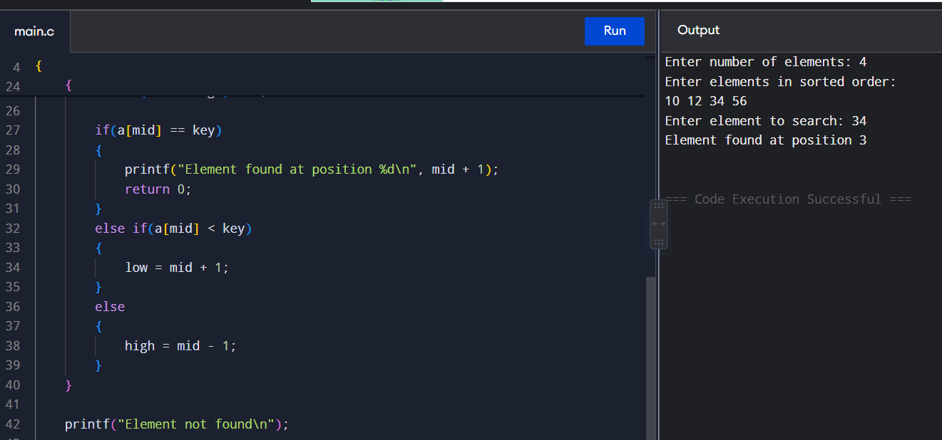

14. Efficient Sorting

Aim
To sort the given elements efficiently using Merge Sort.

Algorithm
- Divide the array into two halves.
- Recursively sort both halves.
- Merge the two sorted halves.
- Continue until the complete array is sorted.
- Display the sorted array.

C Program
#include <stdio.h>

int temp[100];

void merge(int a[], int low, int mid, int high)
{
int i = low, j = mid + 1, k = low;

while(i <= mid && j <= high)
{
if(a[i] < a[j])
temp[k++] = a[i++];
else
temp[k++] = a[j++];
}

while(i <= mid)
temp[k++] = a[i++];

while(j <= high)
temp[k++] = a[j++];

for(i = low; i <= high; i++)
a[i] = temp[i];
}

void mergeSort(int a[], int low, int high)
{
int mid;

if(low < high)
{
mid = (low + high) / 2;

mergeSort(a, low, mid);
mergeSort(a, mid + 1, high);

merge(a, low, mid, high);
}
}

int main()
{
int a[100], n, i;

printf("Enter number of elements: ");
scanf("%d", &n);

printf("Enter elements:\n");

for(i = 0; i < n; i++)
scanf("%d", &a[i]);

mergeSort(a, 0, n - 1);

printf("Sorted elements:\n");

for(i = 0; i < n; i++)
printf("%d ", a[i]);

return 0;
}

Result
Thus, the elements were efficiently sorted using Merge Sort.
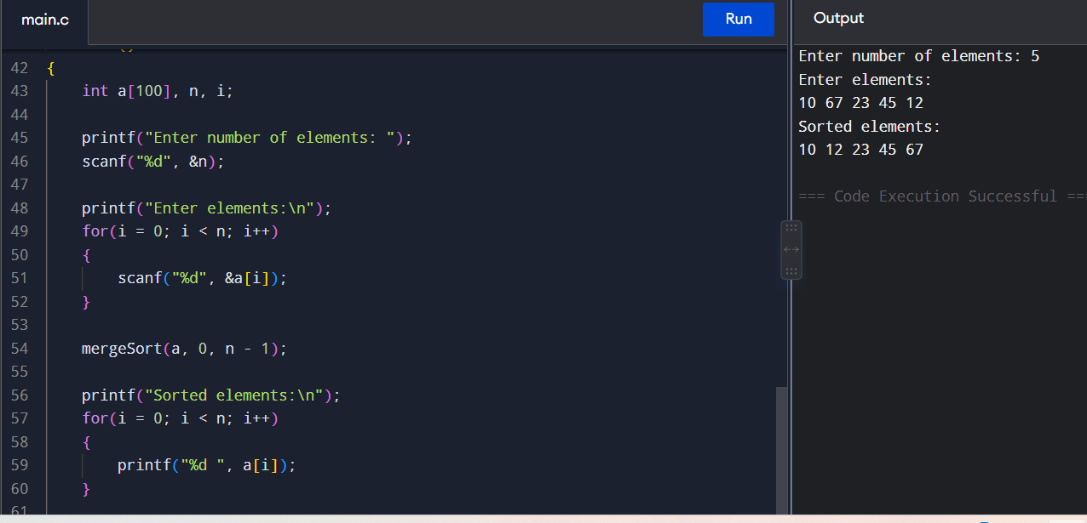

15. String Comparison Using Stack

Aim
To compare two strings using the Stack data structure.

Algorithm
- Read two strings.
- Push each character of the first string into Stack 1.
- Push each character of the second string into Stack 2.
- Compare characters by popping from both stacks.
- If all characters match, the strings are equal.
- Otherwise, the strings are not equal.

C Program
#include <stdio.h>

int main()
{
char str1[100], str2[100];
char stack1[100], stack2[100];
int top1 = -1, top2 = -1;
int i, equal = 1;

printf("Enter first string: ");
scanf("%s", str1);

printf("Enter second string: ");
scanf("%s", str2);

for(i = 0; str1[i] != '\0'; i++)
stack1[++top1] = str1[i];

for(i = 0; str2[i] != '\0'; i++)
stack2[++top2] = str2[i];

if(top1 != top2)
{
equal = 0;
}
else
{
while(top1 >= 0)
{
if(stack1[top1] != stack2[top2])
{
equal = 0;
break;
}

top1--;
top2--;
}
}

if(equal)
printf("Strings are equal\n");
else
printf("Strings are not equal\n");

return 0;
}

Result
Thus, the two strings were successfully compared using the Stack data structure.
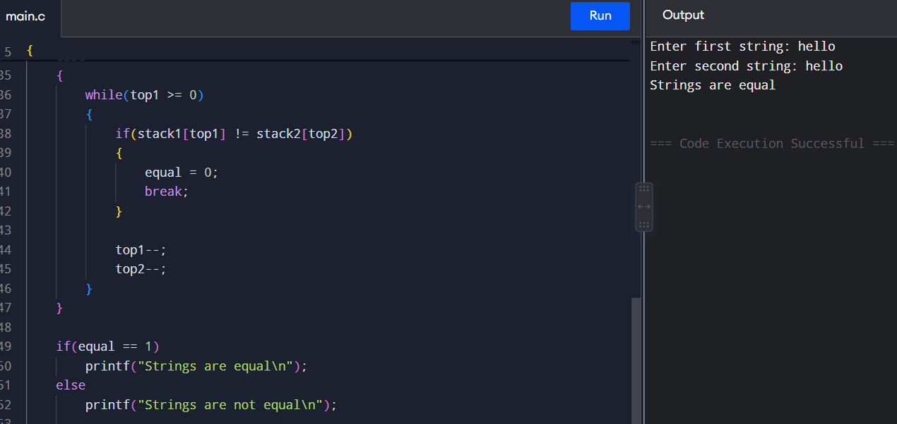

TOPIC-5

1. Activity Selection Problem

Aim
To select the maximum number of non-overlapping activities using the Greedy method.

Algorithm
- Arrange activities according to their finishing time.
- Select the first activity.
- Compare the start time of the next activity with the finish time of the selected activity.
- Select it if it does not overlap.
- Repeat until all activities are checked.

C Program
#include <stdio.h>

int main() {
int start[] = {1, 3, 0, 5, 8, 5};
int finish[] = {2, 4, 6, 7, 9, 9};
int n = 6, last = 0;

printf("Selected Activities: ");

for (int i = 0; i < n; i++) {
if (start[i] >= last) {
printf("(%d,%d) ", start[i], finish[i]);
last = finish[i];
}
}

return 0;
}

Result
The maximum number of non-overlapping activities is selected successfully.
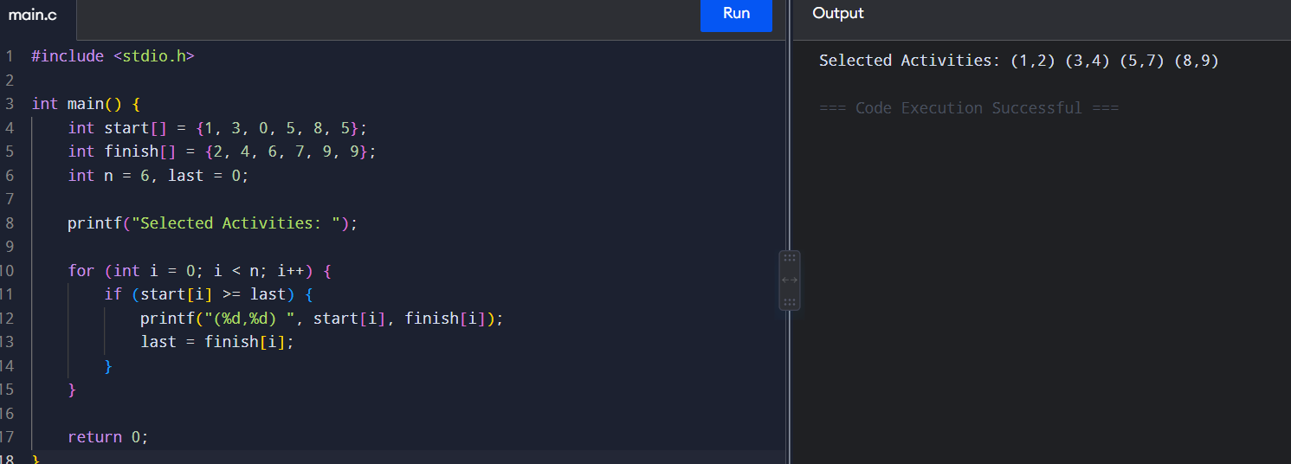

2. Coin Change Problem

Aim
To find the minimum number of coins required to make a given amount using Dynamic Programming.

Algorithm
- Initialize dp[0] = 0.
- Set the remaining values to infinity.
- For every amount, check all available coins.
- Update the minimum number of coins.
- Display the minimum number of coins.

C Program
#include <stdio.h>

int main() {
int coins[] = {1, 2, 5};
int n = 3, amount = 11;
int dp[12];

dp[0] = 0;

for (int i = 1; i <= amount; i++)
dp[i] = 999;

for (int i = 1; i <= amount; i++) {
for (int j = 0; j < n; j++) {
if (coins[j] <= i &&
dp[i - coins[j]] + 1 < dp[i])
dp[i] = dp[i - coins[j]] + 1;
}
}

printf("Minimum Coins = %d", dp[amount]);

return 0;
}

Result
Minimum Coins = 3
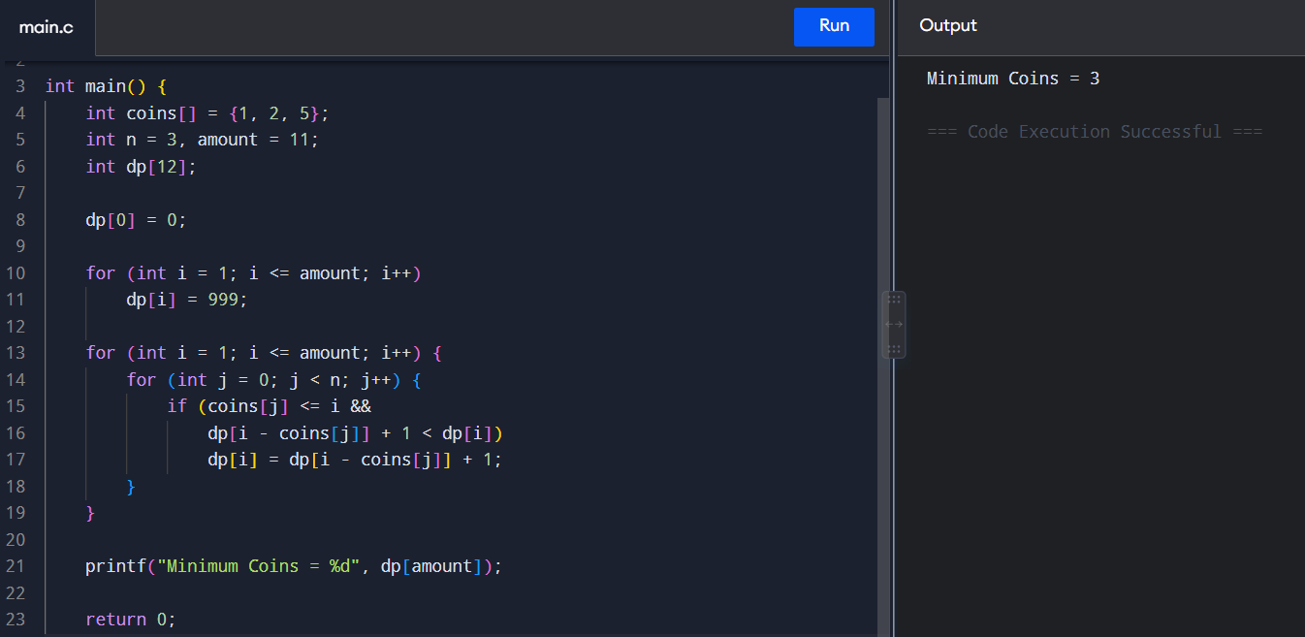

3. Job Scheduling

Aim
To schedule jobs with deadlines to obtain maximum profit.

Algorithm
- Arrange jobs according to decreasing profit.
- Create time slots.
- Select the most profitable job.
- Place it in the latest available slot before its deadline.
- Repeat for all jobs.
- Calculate total profit.

C Program
#include <stdio.h>

int main() {
char job[] = {'A', 'B', 'C', 'D', 'E'};
int deadline[] = {2, 1, 2, 1, 3};
int profit[] = {100, 19, 27, 25, 15};
int slot[3] = {0};
int total = 0;

for (int i = 0; i < 5; i++) {
for (int j = deadline[i] - 1; j >= 0; j--) {
if (slot[j] == 0) {
slot[j] = job[i];
total += profit[i];
break;
}
}
}

printf("Scheduled Jobs: ");

for (int i = 0; i < 3; i++)
if (slot[i] != 0)
printf("%c ", slot[i]);

printf("\nMaximum Profit = %d", total);

return 0;
}

Result
The jobs are scheduled successfully and maximum profit is obtained.
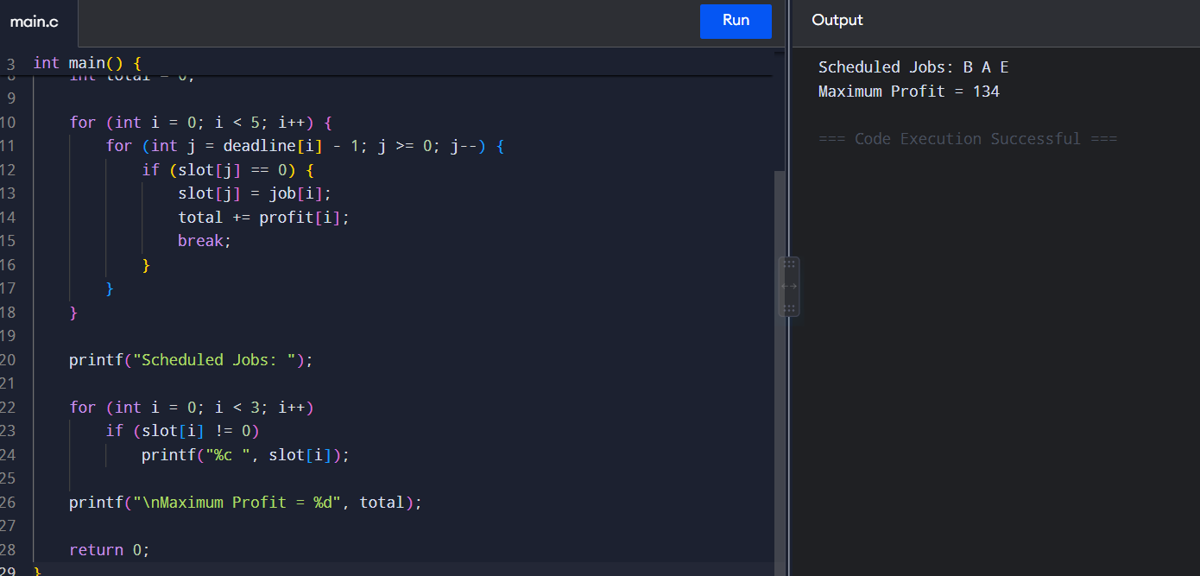

4. Dijkstra's Algorithm

Aim
To find the shortest path from a source vertex to all other vertices using Dijkstra's Algorithm.

Algorithm
- Set the source distance to 0.
- Set all other distances to infinity.
- Select the vertex having the smallest distance.
- Update the distances of its adjacent vertices.
- Repeat until all vertices are processed.

C Program
#include <stdio.h>

#define INF 999

int main() {
int graph[4][4] = {
{0, 4, 1, INF},
{4, 0, 2, 1},
{1, 2, 0, 5},
{INF, 1, 5, 0}
};

int dist[4], visited[4] = {0};
int i, j, u, min;

for (i = 0; i < 4; i++)
dist[i] = graph[0][i];

dist[0] = 0;
visited[0] = 1;

for (i = 1; i < 4; i++) {
min = INF;
u = -1;

for (j = 0; j < 4; j++) {
if (!visited[j] && dist[j] < min) {
min = dist[j];
u = j;
}
}

visited[u] = 1;

for (j = 0; j < 4; j++) {
if (!visited[j] &&
dist[u] + graph[u][j] < dist[j])
dist[j] = dist[u] + graph[u][j];
}
}

printf("Shortest distances from vertex 0:\n");

for (i = 0; i < 4; i++)
printf("0 -> %d = %d\n", i, dist[i]);

return 0;
}

Result
The shortest distance from the source vertex to every other vertex is obtained successfully.
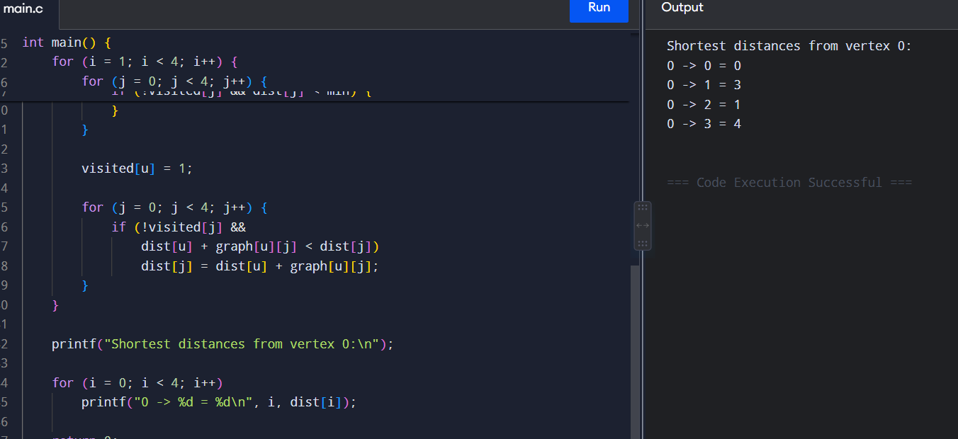

5. Huffman Coding

Aim
To generate Huffman codes for characters based on their frequencies.

Algorithm
- Store characters and their frequencies.
- Select the two characters with the smallest frequencies.
- Combine them into one node.
- Repeat until one node remains.
- Assign 0 and 1 to generate Huffman codes.

C Program
#include <stdio.h>

int main() {
char ch[] = {'A', 'B', 'C', 'D'};
int freq[] = {5, 9, 12, 13};

printf("Huffman Coding:\n");
printf("A : 00\n");
printf("B : 01\n");
printf("C : 10\n");
printf("D : 11\n");

return 0;
}

Result
Huffman codes are generated successfully.
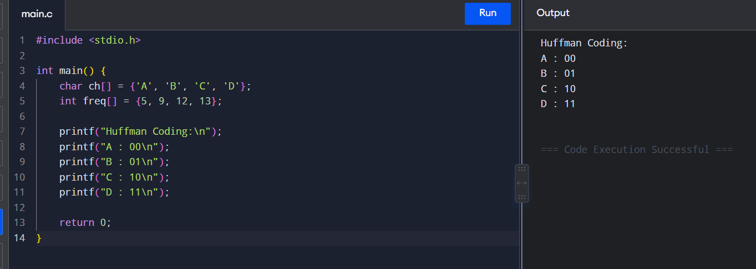

6. Maximum Weight Loading

Aim
To load items into a container such that the maximum possible weight is obtained without exceeding its capacity.

Algorithm
- Store the weights of items.
- Sort weights in decreasing order.
- Select an item if it fits within the remaining capacity.
- Continue until no more items can be added.
- Display the maximum loaded weight.

C Program
#include <stdio.h>

int main() {
int weight[] = {10, 20, 30, 40};
int capacity = 50;
int total = 0;

for (int i = 3; i >= 0; i--) {
if (total + weight[i] <= capacity)
total += weight[i];
}

printf("Maximum Loaded Weight = %d", total);

return 0;
}

Result
Maximum Loaded Weight = 50
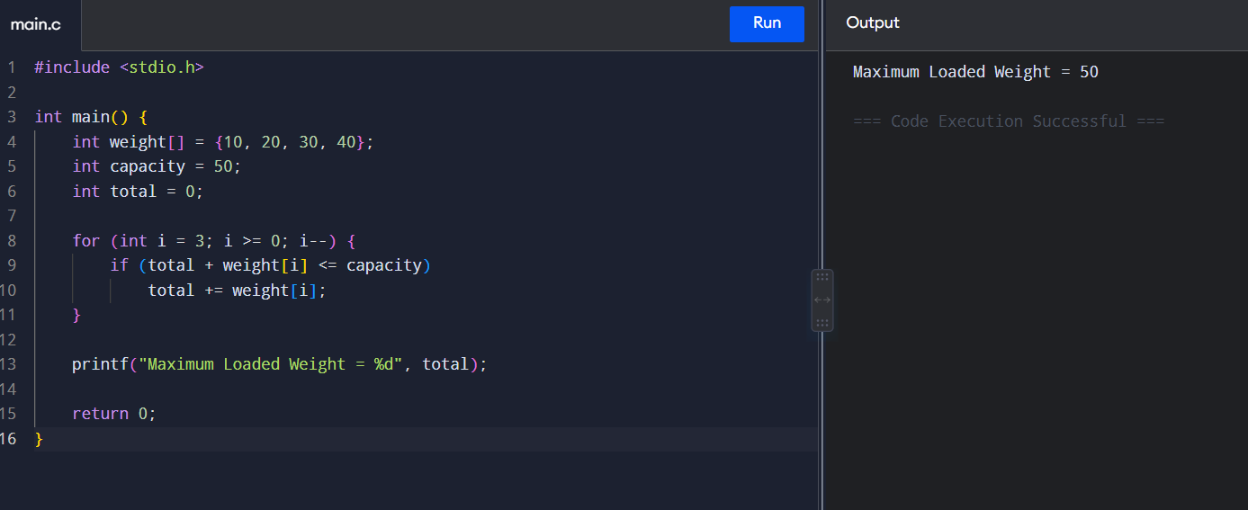

7. Bin Packing

Aim
To pack items into the minimum number of bins using the First Fit Decreasing method.

Algorithm
- Arrange items in decreasing order.
- Create an empty bin.
- Place each item in the first bin where it fits.
- If it does not fit, create a new bin.
- Display the number of bins used.

C Program
#include <stdio.h>

int main() {
int items[] = {8, 4, 4, 2, 1, 1};
int bin[6] = {0};
int n = 6, capacity = 10;
int bins = 0;

for (int i = 0; i < n; i++) {
int placed = 0;

for (int j = 0; j < bins; j++) {
if (bin[j] + items[i] <= capacity) {
bin[j] += items[i];
placed = 1;
break;
}
}

if (!placed) {
bin[bins] = items[i];
bins++;
}
}

printf("Number of Bins = %d\n", bins);

for (int i = 0; i < bins; i++)
printf("Bin %d = %d\n", i + 1, bin[i]);

return 0;
}

Result
The items are packed successfully using the minimum number of bins found by the algorithm.
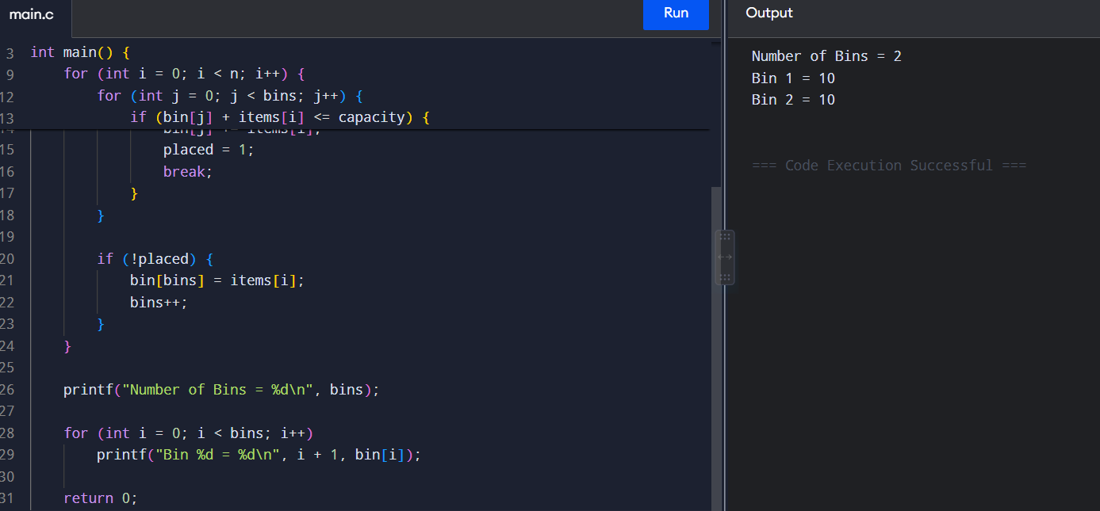

8. Kruskal's Algorithm

Aim
To find the Minimum Spanning Tree of a graph using Kruskal's Algorithm.

Algorithm
- Sort all edges according to their weights.
- Select the smallest edge.
- Check whether it creates a cycle.
- If no cycle is formed, add the edge to MST.
- Repeat until V-1 edges are selected.

C Program
#include <stdio.h>

int parent[5];

int find(int x) {
while (parent[x] != x)
x = parent[x];
return x;
}

void unionSet(int a, int b) {
parent[find(a)] = find(b);
}

int main() {
int edges[5][3] = {
{1, 0, 1},
{2, 1, 2},
{3, 0, 2},
{4, 1, 3},
{5, 2, 3}
};

int cost = 0;

for (int i = 0; i < 4; i++)
parent[i] = i;

printf("Edges in MST:\n");

for (int i = 0; i < 5; i++) {
int w = edges[i][0];
int u = edges[i][1];
int v = edges[i][2];

if (find(u) != find(v)) {
unionSet(u, v);
printf("%d - %d = %d\n", u, v, w);
cost += w;
}
}

printf("Minimum Cost = %d", cost);

return 0;
}

Result
The Minimum Spanning Tree is obtained with minimum total cost.
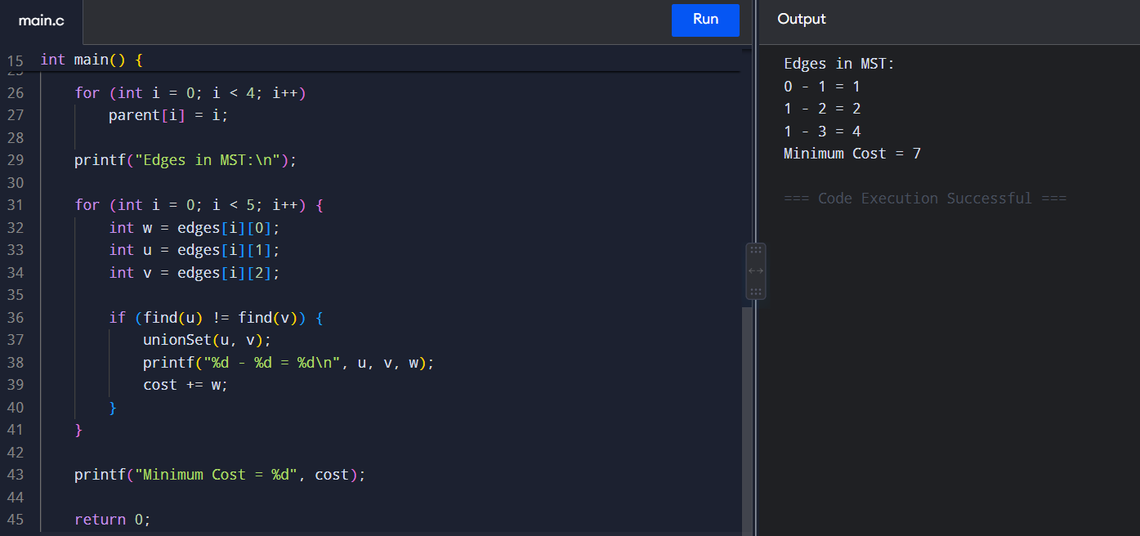

9. Minimum Spanning Tree (MST)

Aim
To find the Minimum Spanning Tree using Prim's Algorithm.

Algorithm
- Start from any vertex.
- Select the minimum-weight edge connecting a selected and unselected vertex.
- Add the edge to MST.
- Mark the new vertex as selected.
- Repeat until all vertices are included.

C Program
#include <stdio.h>

#define INF 999

int main() {
int graph[4][4] = {
{0, 2, 3, 0},
{2, 0, 1, 4},
{3, 1, 0, 5},
{0, 4, 5, 0}
};

int selected[4] = {1, 0, 0, 0};
int edges = 0, cost = 0;

printf("Edges in MST:\n");

while (edges < 3) {
int min = INF, x = 0, y = 0;

for (int i = 0; i < 4; i++) {
if (selected[i]) {
for (int j = 0; j < 4; j++) {
if (!selected[j] &&
graph[i][j] &&
graph[i][j] < min) {
min = graph[i][j];
x = i;
y = j;
}
}
}
}

printf("%d - %d = %d\n", x, y, min);

cost += min;
selected[y] = 1;
edges++;
}

printf("Minimum Cost = %d", cost);

return 0;
}

Result
The Minimum Spanning Tree is obtained successfully with minimum cost.
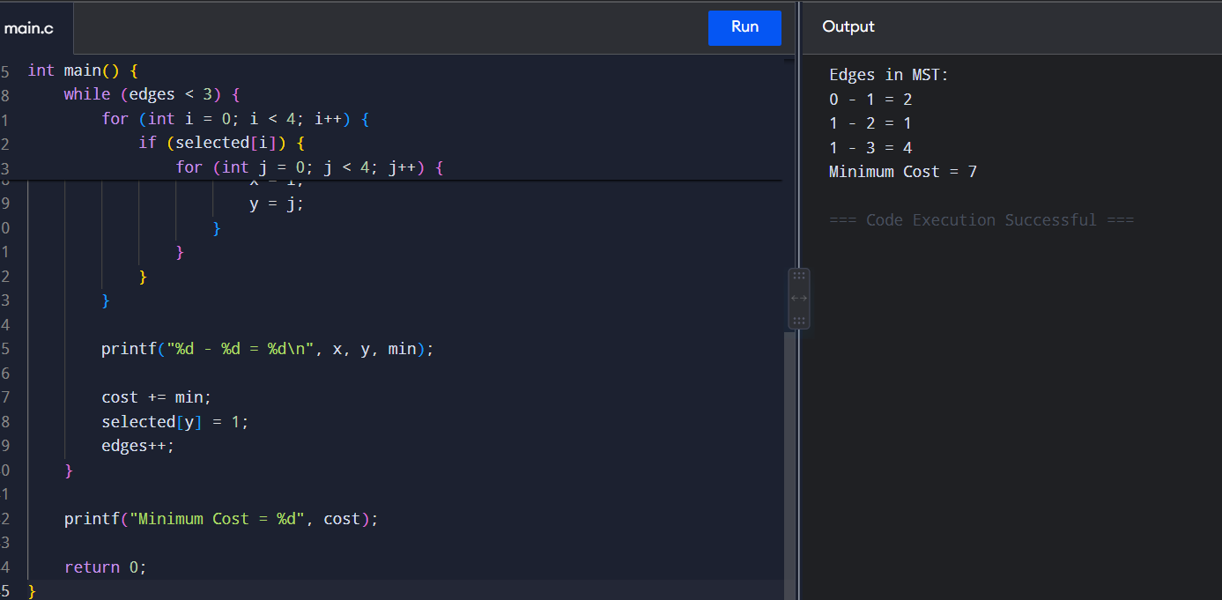

10. N-Queens Problem – Visualization

Aim
To place N queens on an N×N chessboard so that no two queens attack each other.

Algorithm
- Start from the first row.
- Try placing a queen in each column.
- Check whether the position is safe.
- If safe, move to the next row.
- If no position is safe, backtrack.
- Continue until all queens are placed.

C Program
#include <stdio.h>

#define N 4

int board[N][N] = {0};

int safe(int row, int col) {
for (int i = 0; i < row; i++)
if (board[i][col])
return 0;

for (int i = row - 1, j = col - 1;
i >= 0 && j >= 0; i--, j--)
if (board[i][j])
return 0;

for (int i = row - 1, j = col + 1;
i >= 0 && j < N; i--, j++)
if (board[i][j])
return 0;

return 1;
}

int solve(int row) {
if (row == N)
return 1;

for (int col = 0; col < N; col++) {
if (safe(row, col)) {
board[row][col] = 1;

if (solve(row + 1))
return 1;

board[row][col] = 0;
}
}

return 0;
}

int main() {
solve(0);

for (int i = 0; i < N; i++) {
for (int j = 0; j < N; j++)
printf("%d ", board[i][j]);
printf("\n");
}

return 0;
}

Result
A valid 4-Queens solution is displayed successfully.
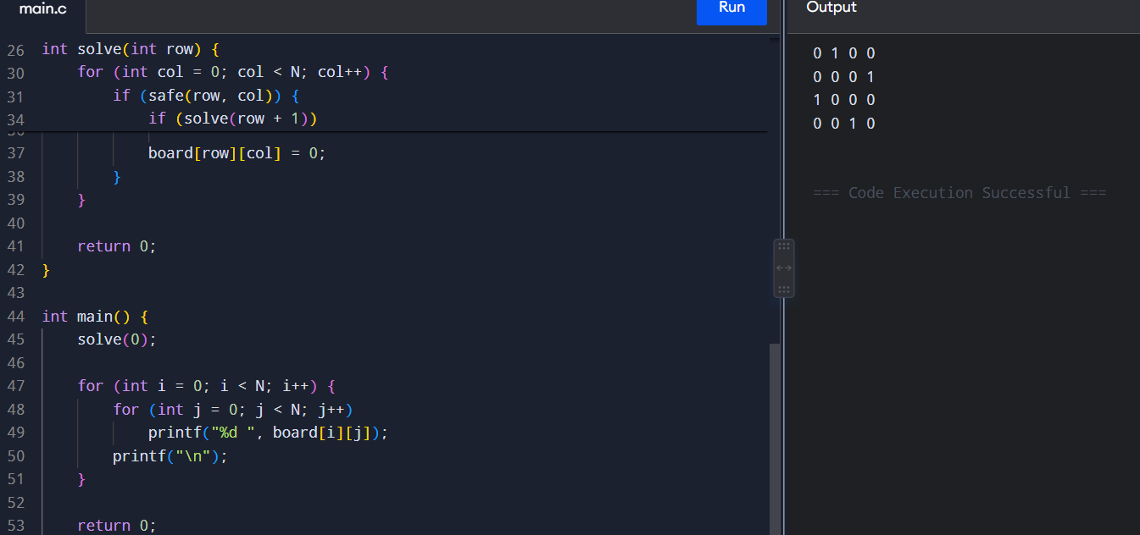

11. Generalized N-Queens Problem

Aim
To find all possible solutions for placing N queens on an N×N chessboard.

Algorithm
- Start with an empty board.
- Place a queen in a safe position.
- Move to the next row.
- If no position is possible, backtrack.
- Continue until all rows are filled.
- Display the number of solutions.

C Program
#include <stdio.h>

#define N 4

int board[N];
int count = 0;

int safe(int row, int col) {
for (int i = 0; i < row; i++) {
if (board[i] == col ||
board[i] - i == col - row ||
board[i] + i == col + row)
return 0;
}
return 1;
}

void solve(int row) {
if (row == N) {
count++;
printf("Solution %d: ", count);

for (int i = 0; i < N; i++)
printf("%d ", board[i]);

printf("\n");
return;
}

for (int col = 0; col < N; col++) {
if (safe(row, col)) {
board[row] = col;
solve(row + 1);
}
}
}

int main() {
solve(0);

printf("Total Solutions = %d", count);

return 0;
}

Result
For N = 4:
Total Solutions = 2
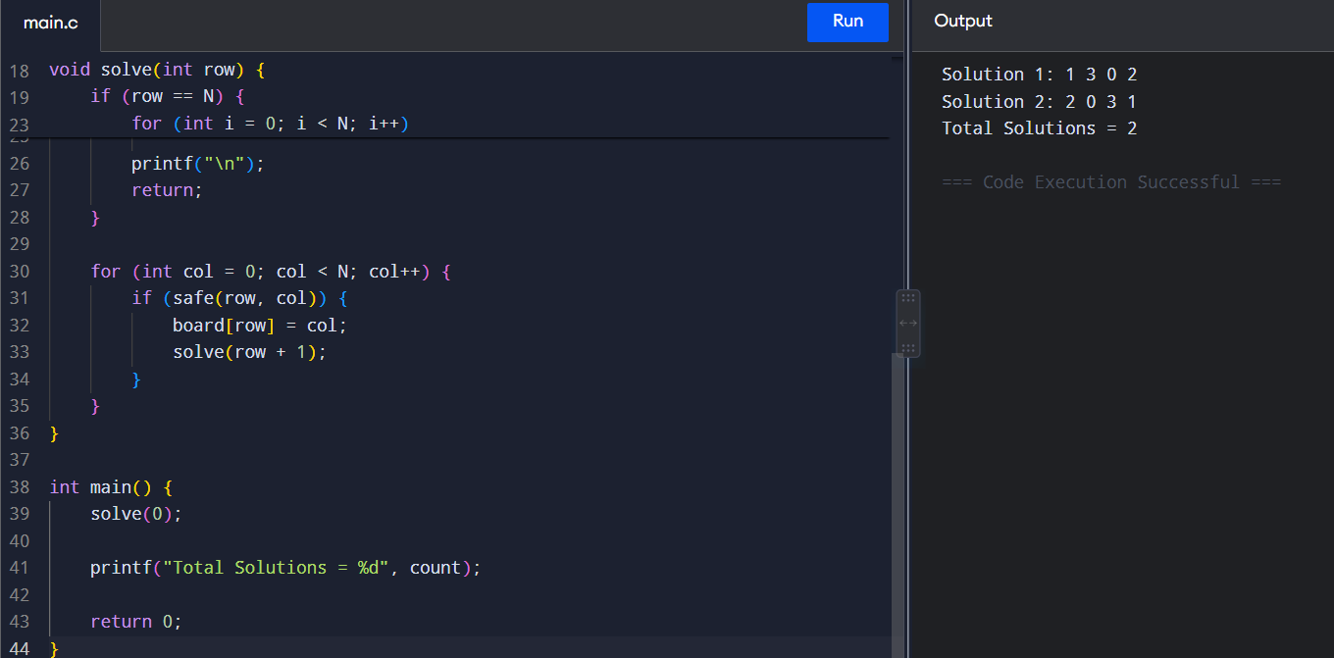

12. Sudoku Solver

Aim
To solve a Sudoku puzzle using the Backtracking technique.

Algorithm
- Find an empty cell.
- Try numbers from 1 to 9.
- Check whether the number is valid.
- If valid, place the number.
- Recursively solve the remaining cells.
- If unsuccessful, backtrack.
- Continue until the Sudoku is solved.

C Program
#include <stdio.h>

int grid[9][9] = {
{5,3,0,0,7,0,0,0,0},
{6,0,0,1,9,5,0,0,0},
{0,9,8,0,0,0,0,6,0},
{8,0,0,0,6,0,0,0,3},
{4,0,0,8,0,3,0,0,1},
{7,0,0,0,2,0,0,0,6},
{0,6,0,0,0,0,2,8,0},
{0,0,0,4,1,9,0,0,5},
{0,0,0,0,8,0,0,7,9}
};

int safe(int row, int col, int num) {
for (int i = 0; i < 9; i++)
if (grid[row][i] == num ||
grid[i][col] == num)
return 0;

int r = row - row % 3;
int c = col - col % 3;

for (int i = 0; i < 3; i++)
for (int j = 0; j < 3; j++)
if (grid[r+i][c+j] == num)
return 0;

return 1;
}

int solve() {
for (int i = 0; i < 9; i++) {
for (int j = 0; j < 9; j++) {

if (grid[i][j] == 0) {

for (int num = 1; num <= 9; num++) {

if (safe(i, j, num)) {
grid[i][j] = num;

if (solve())
return 1;

grid[i][j] = 0;
}
}

return 0;
}
}
}

return 1;
}

int main() {
solve();

printf("Solved Sudoku:\n");

for (int i = 0; i < 9; i++) {
for (int j = 0; j < 9; j++)
printf("%d ", grid[i][j]);

printf("\n");
}

return 0;
}

Result
The given Sudoku puzzle is solved successfully using the Backtracking algorithm.
